

AAVISHKAR INSTITUTE

DEVELOPED BY: TANU SHAMRA

­

CHAPTER**:**1

Introduction & Object of Project

Introduction

This project is specially designed for Students, because in this project students can take online Admission from Aavishkar Institute from their home which is registered in this project. Students can apply for admission through our project “Aavishkar Institute”. As well as students can also get online material.

The “Aavishkar Institute” project is a multi-user system. It has been developed in a way that allows user to perform the function smoothly and with proper accuracy.

The system is developed in ASP.NET and some other software use like SQL Server, and also used Java Script and CSS for designing purpose.

How It Works?

In this project first of all a homepage is displayed for all visitors as well as registered students/users.

If user wants to take admission, then they have to Login first. If the user is not a Registered User, he/she will have to click on the Signup Button and fill all the fields in the registration form.

After registering you can see login page. Users will have to login with their registered mobile number and password.

After login, user will see User-Panel of ‘Aavishkar Institute’ Website. User can simply apply for admission by filling all the required details.

CHAPTER**:**2

Tools or Platform

Requirement Details

* Software:
* SQL Server
* Any browser like Google Chrome, Internet Explorer, etc.
* Hardware:
* Processor: Intel Core i3
* RAM: 8.00 GB
* Hard Disk: 1.00 TB
* Tools Used:
* Front End: HTML, CSS, JavaScript
* Back End: ASP.NET
* Operating System: Windows 8 or Higher

CHAPTER**:**3

System Analysis

3.1 Identification of Needs

3.2 Preliminary Investigation

3.3 Feasibility Study

3.4 Project Planning

3.5 Project Scheduling (PERT Chart and GANTT Chart)

3.6 Software Requirement Specification

3.7 Data Models

3.8 Normalization

3.1 Identification of Needs

The viewer of our system does not need to login as long as User wants to browse information about Aavishkar Institute only. But if the User wants to apply for admission in Aavishkar Institute, then he/she must be registered to our website.

User needs to provide name, email, mobile number and password when creating an account.

SDLC Model

Planning

Analysis

Coding

Designing

Testing

Implementation & Maintenance

SDLC Steps

* Step 1: Requirement Gathering

In this phase of SDLC necessary information are collected. We collect the information in this phase through questionnaire and online websites also. We also note down the requirements of the User.

* Step 2: Requirement Specification & Analysis

The requirements are being specified in this phase. Analyst checks how the current system is working and then plans how to develop the proposed system and implement it.

* Step 3: Design

In this phase the design of both front-end and back-end is decided. In this phase we use HTML, CSS for designing, and designing of tables are also done properly in this phase.

* Step 4: Coding

After the completion of designing there is a turn for coding. Coding is completed in various files. In most of the cases coding takes much more time than designing.

* Step 5: Testing

In testing phase first unit level testing is done. In unit level testing the software is tested in an individual file. After the unit testing of each file, the integration testing done. In integration testing the files are tested into their own package. At last, in the system testing the whole system is run on the Internet Environment.

* Step 6: Maintenance

The proper maintenance is given as indicated in the SRS (Software Requirement Specification). It is a responsibility of Developer to maintain the software during its criteria mentioned in SRS document.

3.2 Preliminary Investigation

* Our Objectives
* Admin can Add, Delete and Edit records.
* User can learn about various courses.
* User can handle all type of information easily.
* User can contact us at any time, for any query.
* Easy updating, time saving, quick process.
* User can update their sign-up details.
* User can simply apply for admission by filling the admission form.
* Students can get online material.

* Platform Specification

I have used windows based developing & graphical based applications; our software will provide support for GUI efficiently. It is must for our system because for our project.

It is very useful and supportive for ASP.NET and Java Script to control the components. There is use of CSS for menu creation and display web page in it. It’s easy to use integrity database report with Data Report.

ASP.NET platform is mostly use for developing web-based application, regular version of operating system is used with it. Always need the back-end tool for developing web application with front-end tool.

When starting a new business, organizations have some requirement for it. There are many reasons for starting a new business or modify the old system.

Business requirement set depends on the top-level organization i.e., manager, administrator etc.

3.3 Feasibility Study

A feasibility analysis usually involves a thorough assessment of the operational(need), financial and technical aspects of a proposal.

Feasibility study is the test of the system proposal made to identify whether the user needs may be satisfied using the current software and hardware technologies, whether the system will be cost effective from a business point of view and whether it can be developed with the given budgetary constraints.

A feasibility study should be relatively cheap and done at the earliest possible time.

Depending on the study, the decision is made whether to go ahead with a more detailed analysis.

When a new project is proposed, it normally goes through feasibility assessment.

Feasibility study is carried out to determine whether the proposed system is possible to develop with available resources and what should be the cost consideration.

Facts considered in the feasibility analysis are:

1. Technical Feasibility

A technical feasibility study for a website project like Aavishkar Institute, which allows users to take online admission, covers the following aspects:

1. **Technical Requirements:** The technical requirements of the website are ASP.NET web framework that uses C#, and SQL Server database is used to build the website.
2. **User Interface:** The user interface is a crucial component of any website, particularly for online admission sites. Using CSS and JavaScript in the user interface of our website has helped us create an engaging and visually appealing user experience.
3. **Security:** Security is another critical aspect of any website that handles sensitive information such as personal and financial details of users. The information we take from user will never be shared to third party. The user credentials will be securely stored and authenticated when logging into the website, as well as how user roles and permissions will be managed.
4. **Performance:** The website can handle a large number of concurrent users and traffic spikes without affecting its performance. It covers the scalability and performance metrics required to meet the expected user traffic.
5. **Compatibility:** The website is compatible with various devices, including laptops, tablets, and mobile devices.
6. **Maintenance:** Maintenance is the very important part of any website. The website will require a system and software upgrade within specific period of time to ensure it remains up to date with the latest technology and security standards.
7. **Integration:** If the website needs to integrate with other systems, such as payment gateways or learning management systems, the integration will be designed to ensure the security of user data and prevent any potential data breaches.

Hence, the proposed system is technically feasible.

1. Economical Feasibility Study

Economic justification is generally the “Bottom Line” consideration for most systems. It includes a broad range of concerns that includes cost benefit analysis.

The study takes into account the costs associated with the project, as well as the potential benefits and returns that the project may generate. Here are some key elements that can be included in an economic feasibility study:

1. Cost Analysis**:**

* **Capital Costs:** The cost of equipment, software, and other assets required to offer the courses, such as computers, online learning platforms, or classroom equipment.
* **Operating Costs:** The cost of ongoing expenses such as salaries for teachers and staff, utilities, maintenance, and marketing.
* **Overhead Costs:** The cost of indirect expenses such as rent, insurance, and taxes. The cost of hardware and software for the class of application being considered.

1. Revenue Analysis**:**

* **Course Fees:** The tuition fees charged to students for attending the courses.
* **Enrollment Projections**: The estimated number of students that will enroll in the courses over a given period of time.
* **Revenue Projections:** The estimated revenue generated from course fees based on the enrollment projections.

1. Profitability Analysis**:**

* **Break-even Analysis:** The analysis of how many students need to enroll in the courses for the project to break even financially.
* **Profit Margin Analysis:** The analysis of the profit margin on each course, which is calculated by subtracting the cost of offering the course from the revenue generated by course fees.

1. Sensitivity Analysis**:**

* **Risk Assessment:** Risk assessment is an important component of the economic feasibility study for the Aavishkar Institute website project. The primary risks identified include fluctuations in enrollment, unexpected expenses such as server downtime, and competition from other coaching institutes. These risks have been assessed for their likelihood and impact on the project's financial performance, and contingency plans have been developed to mitigate their potential impact.
* **Scenario analysis:** Scenario analysis has also been conducted to evaluate the project's financial viability under different assumptions and circumstances. Based on varying levels of enrollment and course fees. The results of the scenario analysis indicate that the project is financially feasible, although the level of profitability varies. This analysis has helped to identify potential risks and opportunities and ensure that the project is economically sustainable in different circumstances.

This feasibility checks whether the system can be developed with the available funds. This can be done economically if planned judicially, so it is economically feasible. The cost of project depends upon the number of man hours required.

1. Operational Feasibility Study

It is mainly related to human organizations and political aspects. The points to be considered are:

1. **Organizational Structure:** The current organizational structure of Aavishkar Institute can support the development and maintenance of the proposed website. If necessary, I would consider changes to the organizational structure to ensure that it supports the project effectively.
2. **Resources:** The availability of resources such as personnel, equipment, and facilities are sufficient to support the development and maintenance of the website. If necessary, I would recommend changes or additional resources.
3. **Legal feasibility:** The proposed website complies with relevant laws, regulations, and policies. The potential legal and regulatory risks and requirements are associated with the website.

The system is operationally feasible as it is very easy for the end users to operate it. It only needs basic information about Windows platform.

3.4 Project Planning

|  |  |  |  |  |
| --- | --- | --- | --- | --- |
| No. | Task Name | Start | Finish | Duration |
| 1 | Planning | 02/01/2023 | 08/01/2023 | 1 Week |
| 2 | Analysis | 09/01/2023 | 15/01/2023 | 1 Week |
| 3 | Designing | 16/01/2023 | 24/01/2023 | 1.2 Week |
| 4 | Coding | 25/01/2023 | 09/02/2023 | 2.2 Week |
| 5 | Implementation | 10/02/2023 | 16/02/2023 | 1 Week |
| 6 | Testing | 17/02/2023 | 21/02/2023 | 5 Days |
| Total = 50 Days | | | | |

3.5 Project Scheduling

* Pert Chart

This chart represents the development of our system date wise.

Planning

02/01/2023

Analysis

09/01/2023

Designing

16/01/2023

Coding

25/01/2023

Implementation

10/02/2023

Testing

17/03/2023

Finish

21/02/2023

* Gantt Chart

This is a graphical representation of the date wise development of our project system. It is very similar to the PERT chart except that it is represented graphically.

ID

Task Name

1

2

3

Planning

Analysis

4

5

6

Designing

Coding

Implementation

Testing

02 Jan – 08 Jan

09 Jan - 15 Jan

16 Jan – 24 Jan

25 Jan - 09 Jan

10 Feb - 16 Feb

17 Feb - 21 Feb

Gantt Chart from January to February

3.6 Software Requirement

* ASP.NET

ASP.NET is a popular web application framework developed by Microsoft. It allows developers to build dynamic web applications and services using a variety of programming languages, including C#, Visual Basic, and F#.

ASP.NET offers a range of features that make it an ideal choice for developing web applications, including built-in security features, a rich set of controls and libraries, and support for a wide range of databases.

Some of the key components of ASP.NET include the .NET Framework, which provides a common language runtime and a rich set of libraries for building applications, and the ASP.NET runtime, which provides a set of services for handling requests and managing application state.

In addition, ASP.NET includes a range of tools for developing, debugging, and deploying applications, including Visual Studio, a powerful integrated development environment (IDE), and various command-line tools.

ASP.NET has better language support, a large set of new controls, XML based Components and better Student authentication.

ASP.NET provides increased performance by running compiled code.

ASP.NET code is not fully backward compatible with ASP.

ASP.NET Contains a large set of HTML Controls; almost all HTML elements on a page can be defined as ASP.NET Controls objects that can be controlled by scripts.

Overall, ASP.NET is a powerful and versatile framework that can be used to build a wide range of web applications, from small websites to large-scale enterprise applications.

* C#

C# is an object-oriented programming language from Microsoft that aims to combine the computing power of C++ with the programming ease of Visual Basic. C# is based on C++ and contains features similar to those of Java.

C# is designed to work with Microsoft's .Net platform. Microsoft's aim is to facilitate the exchange of information and services over the Web, and to enable developers to build highly portable applications.

C# simplifies programming through its use of Extensible Markup Language (XML) and Simple Object Access Protocol (SOAP) which allow access to a programming object or method without requiring the programmer to write additional code for each step. Because programmers can build on existing code, rather than repeatedly duplicating it, C# is expected to make it faster and less expensive to get new products and services to market.

Microsoft is collaborating with ECMA (European Computer Manufacturers Association), the international standards body, to create a standard for C#. International Organization for Standardization (ISO) recognition for C# would encourage other companies to develop their own versions of the language. Companies that are already using C# include Apex Software, Bunka Orient, Component Source, devSoft, FarPoint Technologies, LEAD (Leadership for Environment & Development) Technologies, ProtoView, and Seagate Software.

* SQL Server

SQL Server is a relational database management system (RDBMS) from Microsoft that's designed for the enterprise environment. SQL Server runs on T-SQL (Transact -SQL), a set of programming extensions from Sybase and Microsoft that add several features to standard SQL, including transaction control, exception and error handling, row processing, and declared variables.

Code named Yukon in development; SQL Server 2005 was released in November 2005. The 2005 product is said to provide enhanced flexibility, scalability, reliability, and security to database applications, and to make them easier to create and deploy, thus reducing the complexity and tedium involved in database management. SQL Server 2005 also includes more administrative support.

The original SQL Server code was developed by Sybase; in the late 1980s, Microsoft, Sybase and Ashton-Tate collaborated to produce the first version of the product, SQL Server Subsequently, both Sybase and Microsoft offered SQL Server products. Sybase has since renamed their product Adaptive Server Enterprise.

* Java Script
* JavaScript Origins:

JavaScript was released by Netscape and Sun Microsystems in 1995. However, JavaScript is not the same thing as Java.

* It is a programming language.
* It is an interpreted language.
* It is object-based programming.
* It is widely used and supported.
* It is accessible to the beginner.
* Uses of JavaScript:

Use it to add multimedia elements With JavaScript you can show, hide, change, resize images, and create image rollovers. You can create scrolling text across the status bar.

Create pages dynamically Based on the user's choices, the date, or other external data, JavaScript can produce pages that are customized to the user.

* HTML

HTML is the standard Mark-up language for creating web pages and CSS and JavaScript it forms a triad of cornerstone technologies for the WWW.

Web browsers receive HTML documents from a web server or from local storage and render them into multimedia web pages.

HTML describes the structure of a web page semantically and originally included cues for the appearance of the document.

Hyper Text Mark-up Language (HTML) can embed programs written in a scripting language such as JavaScript which affect the behavior and content of web pages.

Inclusion of CSS defines the look and layout of content. The World Wide Web Consortium (W3C), maintainer of both the HTML and the CSS standards, has encouraged the use of CSS over explicit presentational HTML since 1997.

* CSS

Cascading Style Sheet (CSS) is a Style sheet language used for describing the presentation of a document written in a Mark-up language.

Although most often used to set the visual style of web pages and user interfaces written in HTML and XHTML, the language can be applied to any XML document, including plain XML, SVG and XUL, and is applicable to rendering in speech, or on other media.

Along with HTML and JavaScript, CSS is a cornerstone technology used by most websites to create visually engaging web pages, user interfaces for web applications, and user interfaces for many mobile applications.

CSS is designed primarily to enable the separation of presentation and content, including aspects such as the layout, colors, and fonts.

3.7 Data Models

* Data Flow Diagram

1. 0-Level Visitor Data Flow Diagram:

User

Aavishkar Institute

Home

Courses

Admission

Sign Up

Login

About Us

No

Yes

1. 0-Level User Data Flow Diagram:

Aavishkar Institute

Home

Courses

Admission

Feedback

Login

Messages

No

Yes

User

Student Query

Leave Application

Change Password

Profile

1. 0-Level Admin Data Flow Diagram:

No

Yes

Login

Aavishkar Institute

Admissions

Users

Send Message

PDF

Feedback

Courses

Leave Application

­Student Query

Change Password

Admin

Profile

Home

1. 1-Level Visitor Data Flow Diagram:

Aavishkar Institute

Home

Admission

About Us

Courses

Login

user_login

Sign Up

admission

courses

1. 1-Level User Data Flow Diagram:

Aavishkar Institute

Home

Admission

Messages

Stud Query

Leave Application

Feedback

Profile

Change Password

admission

courses

messages

studquery

lv_app

feedback

user_login

Logout

Courses

user_login

1. 1-Level Admin Data Flow Diagram:

Home

Aavishkar Institute

admission

courses

user_ login

messages

studquery

lv_app

pdf

Admissions

Send Message

Stud Query

Leave Application

PDF

Profile

Change Password

Logout

Courses

Users

Feedback

feedback

user_login

user_login

1. 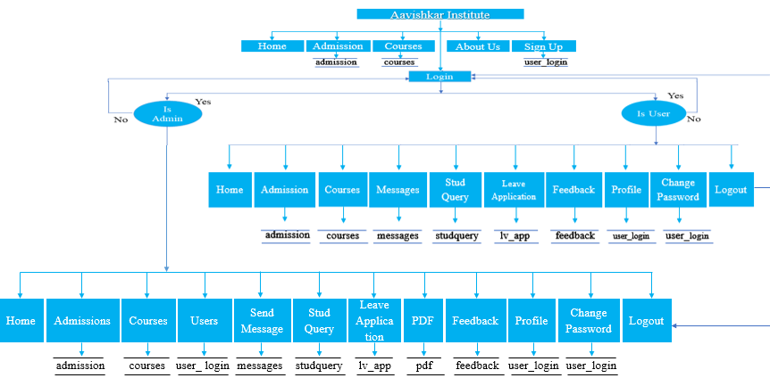Context-Level Visitor, User, Admin Data Flow Diagram:

* ER Diagram

admission

courses

* Use Case Diagram

1. Visitor Use Case Diagram:

Home

Admission

About Us

Courses

Login

Sign Up



1. User Use Case Diagram:

Home

Admission

Messages

Courses

Profile

Leave Application

Feedback

Change Password



Logout

Student Query

1. Admin Use Case Diagram:

Admissions

Courses

Send Message

Users

PDF

Stud Query

Leave Application



Feedback

Logout

Profile

Change Password

Home

* Activity Diagram

User Login

Home

Yes

Apply for Admission

If click

Process for Admission

Admission Confirmed

Yes

Receive Message

Return to Home

No

No

No

No

3.8 Normalization

* Normalization rules are divided into following normal forms:

1. First Normal Form (1NF)

As per First Normal Form, no two rows of data can contain repeating group of information id, each set of columns must have a unique value, such that multiple columns cannot be used to fetch the same row. Each table should be organized into rows, and each row should have a primary key that distinguishes it as unique.

The Primary key is usually a single column, but sometimes more than one column can be combined to create a single primary key. For example, consider a table which is not in First normal form.

1. Second Normal Form (2NF)

As per the Second Normal Form there must not be any partial dependency of any column on primary key. It means that for a table that has concatenated primary key, each column in the table that is not part of the primary key must depend upon the entire concatenated key for its existence. If any column depends only on one part of the concatenated key, then the table fails Second normal form.

In User Table the candidate key will be column. Now, both the above tables qualify for Second Normal Form and will never suffer from update anomalies. Although there are a few complex cases in which table in Second Normal Form suffers update anomalies, and to handle those scenarios Third Normal Form is there.

1. Third Normal Form (3NF)

Third Normal form applies that every non-prime attribute of table must be dependent on primary key, or we can say that, there should not be the case that a non-prime attribute is determined by another non-prime attribute. So, this transitive functional dependency should be removed from the table and also the table must be in Second Normal form. For example, consider a table with following fields.

In this table User id is Primary key, but first name, last name and email depends upon mobile. The dependency between mobile and other fields is called transitive dependency. Hence to apply 3NF, we need to move the first name, last name and email to new table with mobile as primary key.

The advantage of removing transitive dependency is:

* Amount of data duplication is reduced.
* Data integrity is achieved.

CHAPTER**:**4

System Design

4.1 Tables Detail

4.2 Database Structure

4.3 Visitor Interface

4.4 User Interface

4.5 Admin Interface

4.6 Source Code

4.1 Tables Detail

* Visitor Side Table:

1. user_login

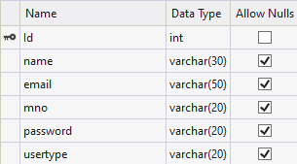

1. courses

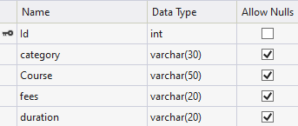

* User Side Table:

1. user_login



1. courses



1. studquery

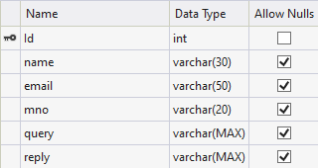

1. admission

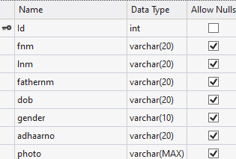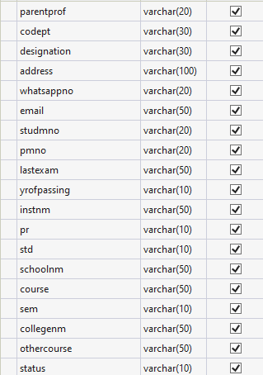

1. lv_app

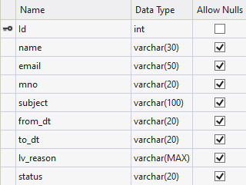

1. feedback

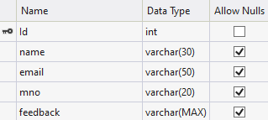

1. messages

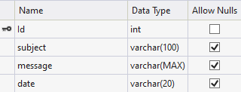

1. pdf

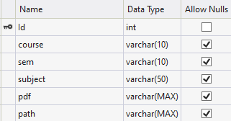

* Admin Side Table:

1. user_login



1. courses



1. messages



1. pdf



1. admission



1. studquery



1. lv_app



1. feedback



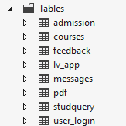

4.2 Database Structure

4.3 Visitor Interface

1. Home Page: This is home page for visitor.

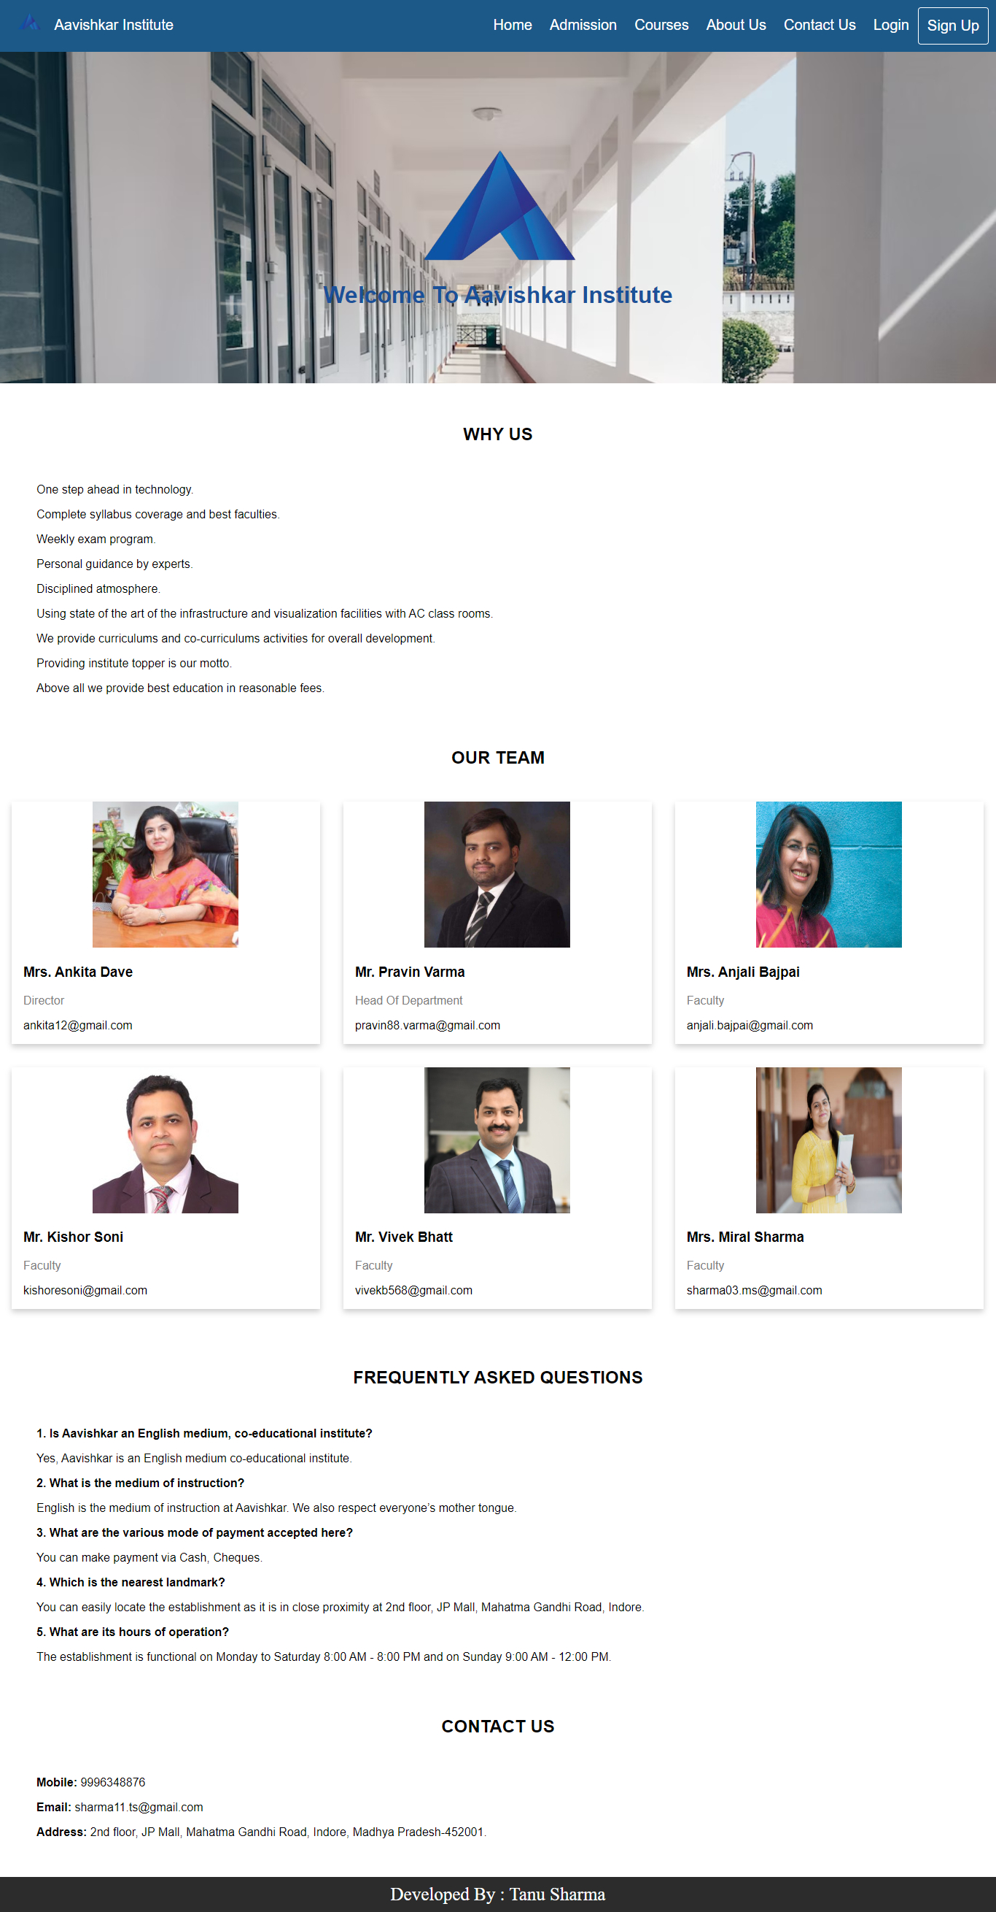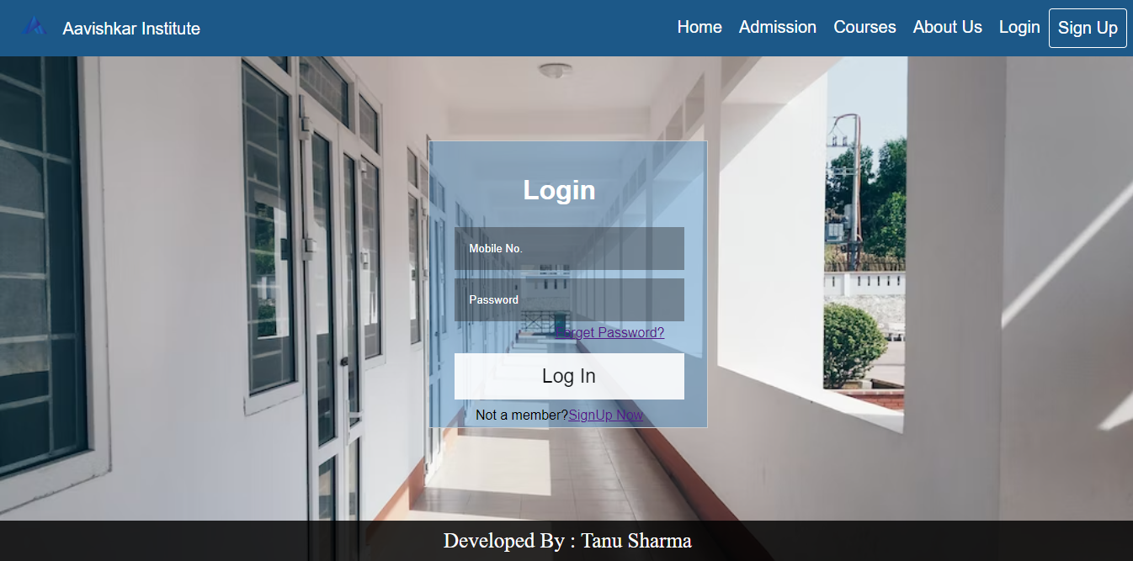

1. Admission Page: User must login to apply for admission.



1. Courses Page: Visitor can see courses information.

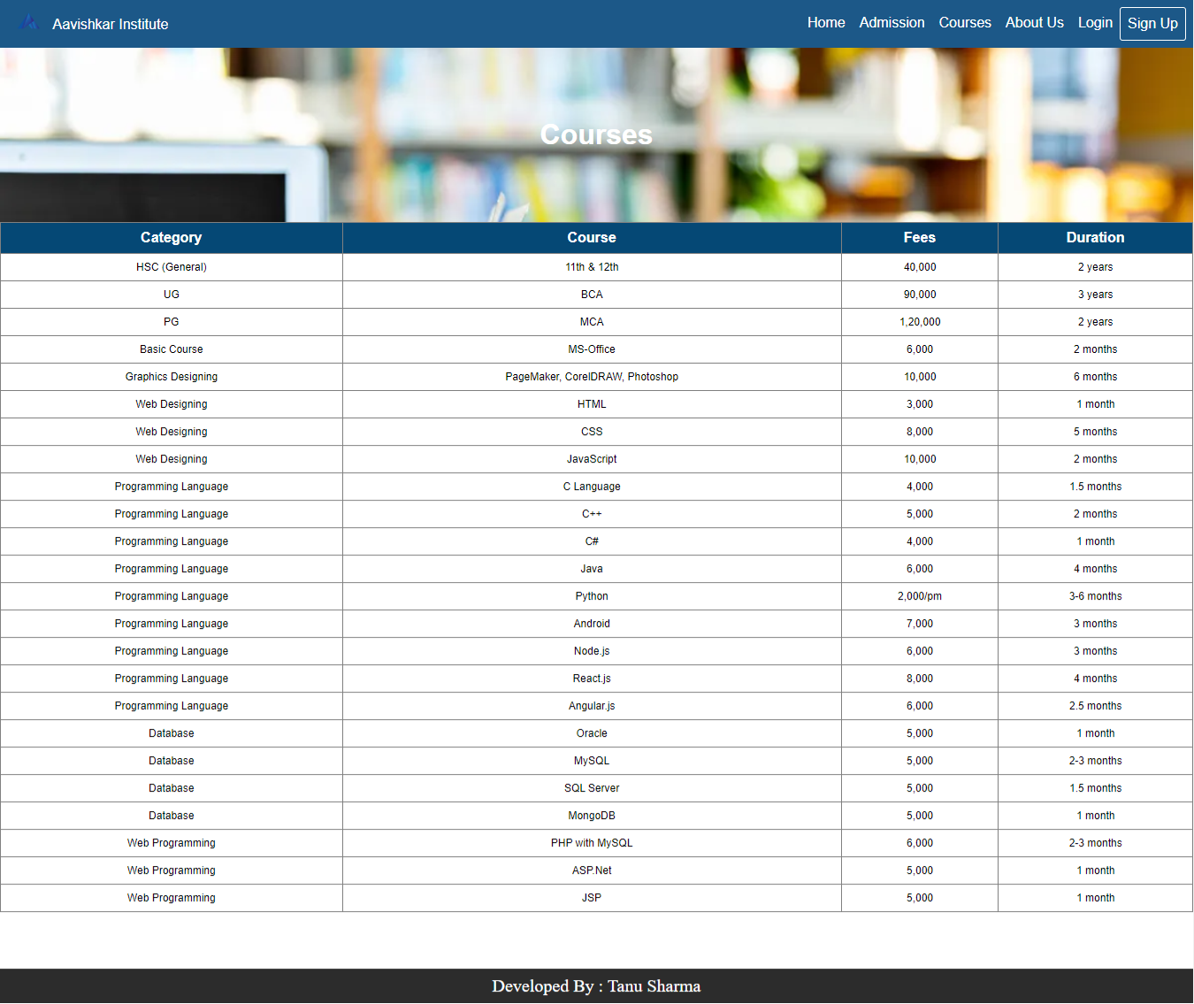

1. About Us Page: This page describes about “Aavishkar Institute”.
2. Login Page: Existing user can simply login with his mobile no. and password.
3. Sign Up Page: New user can simply sign up by providing required details.

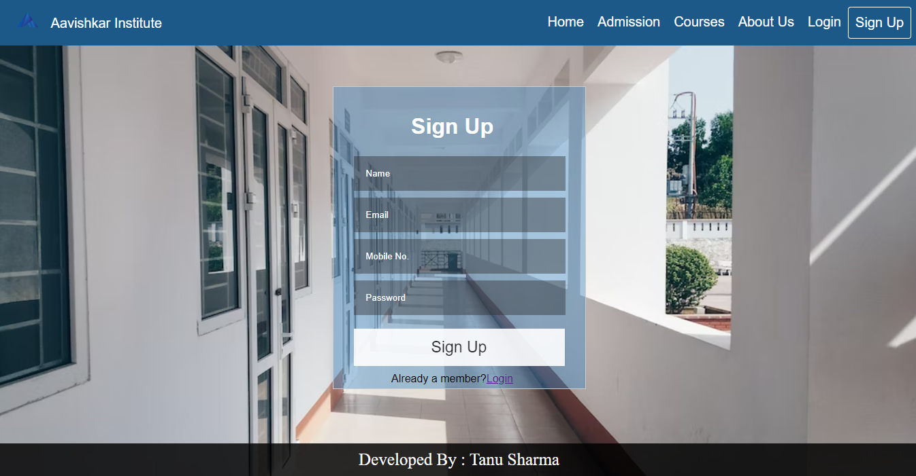

4.4 User Interface

1. Home Page: After user login, a home page is displayed.



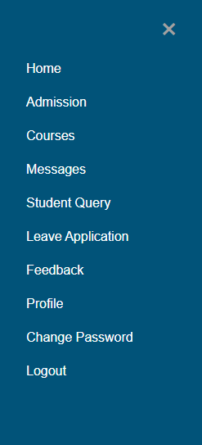On header ,there’s a menu button. User can open it and go to the particular page.

1. Admission Page: Here user can apply for admission.

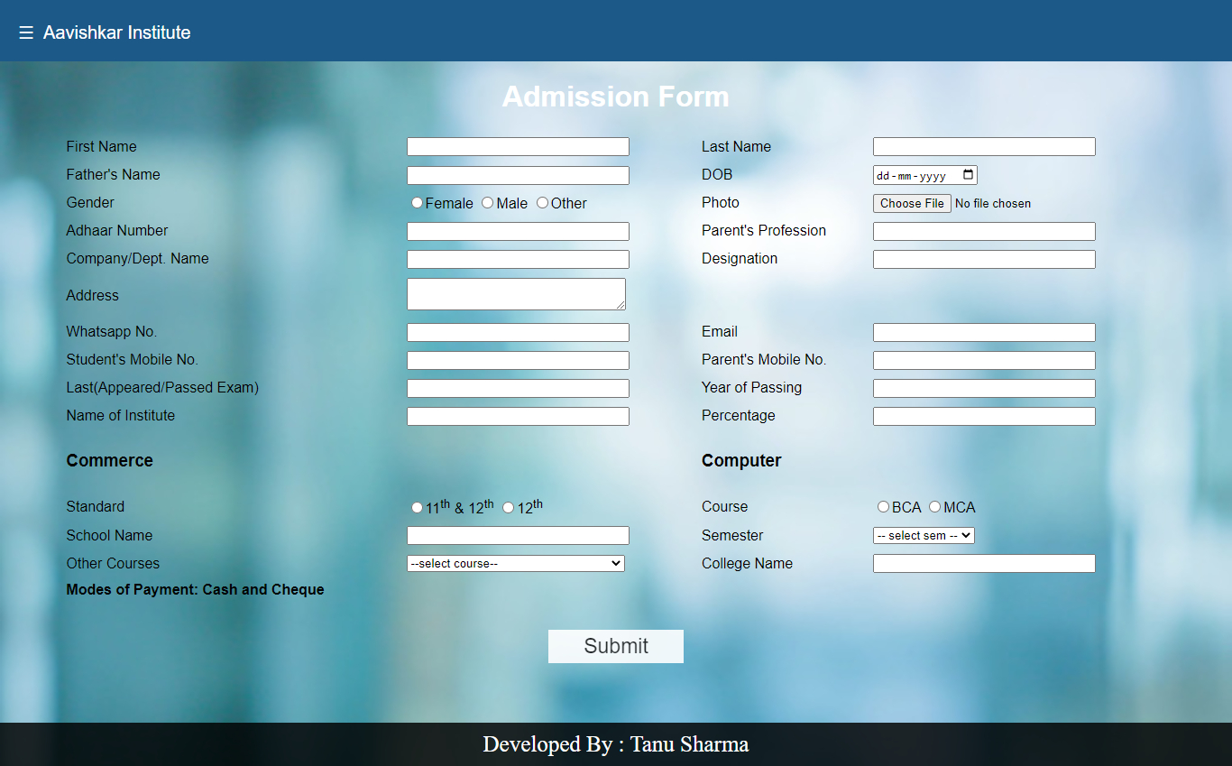

1. Courses Page: User can see courses information.

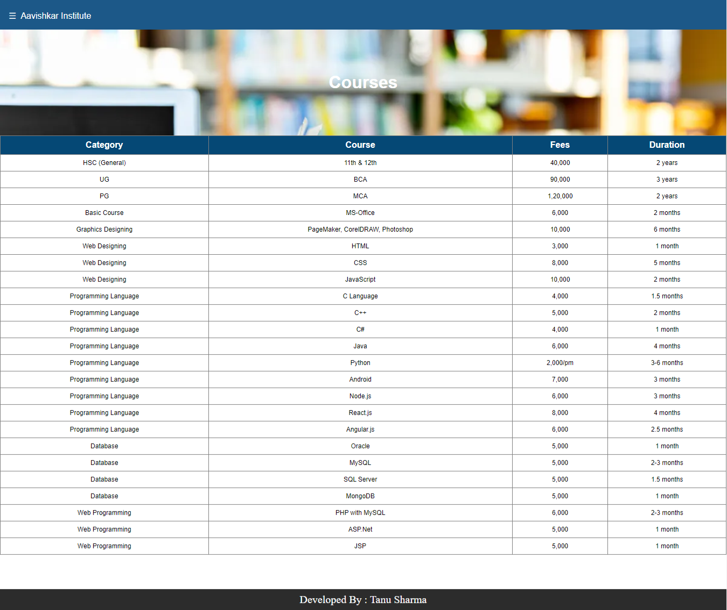

1. Messages Page: Students can see messages send by admin.

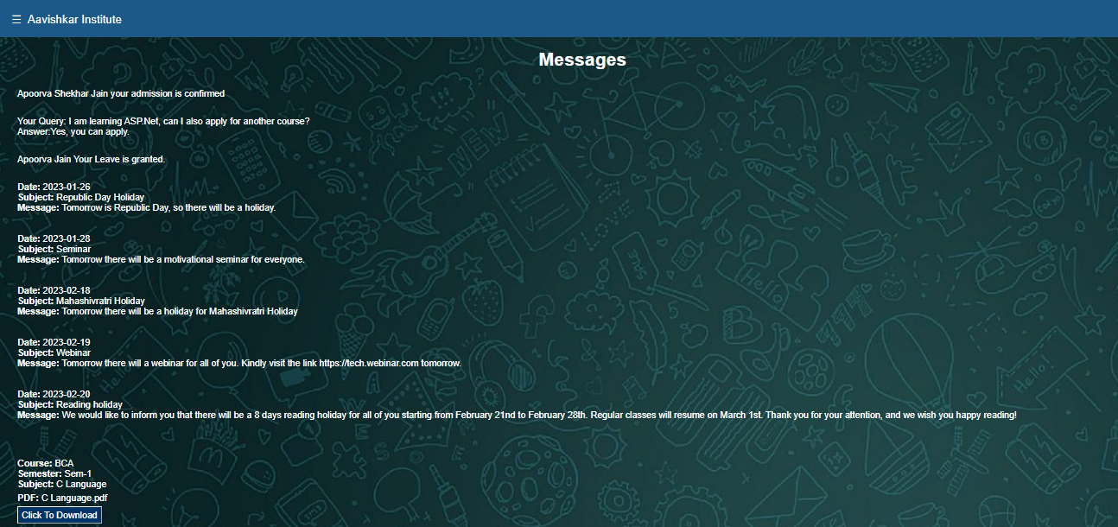

1. Student Query Page: Here students can ask their queries.

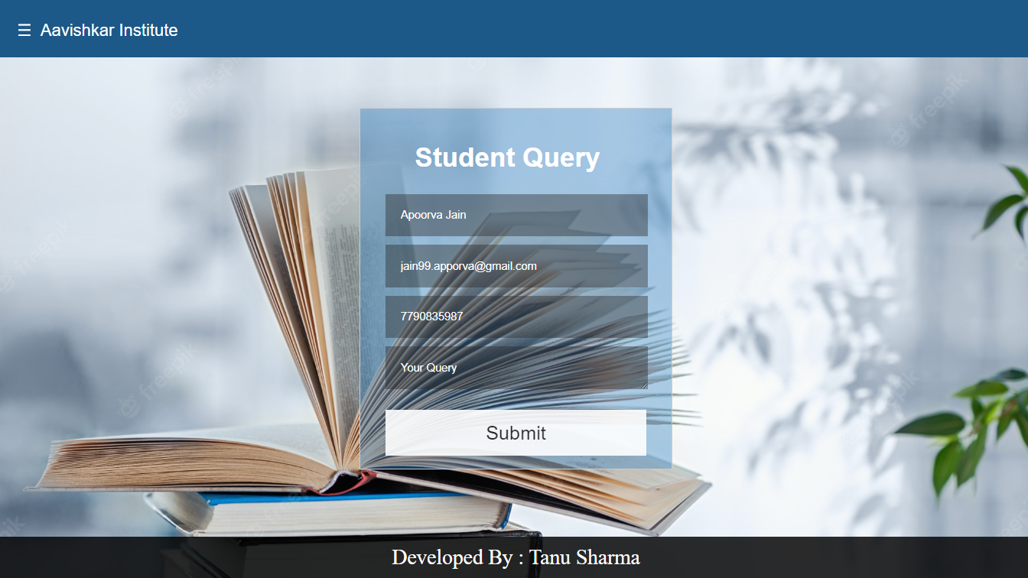

1. Leave Application Page: Here students can apply for leave.

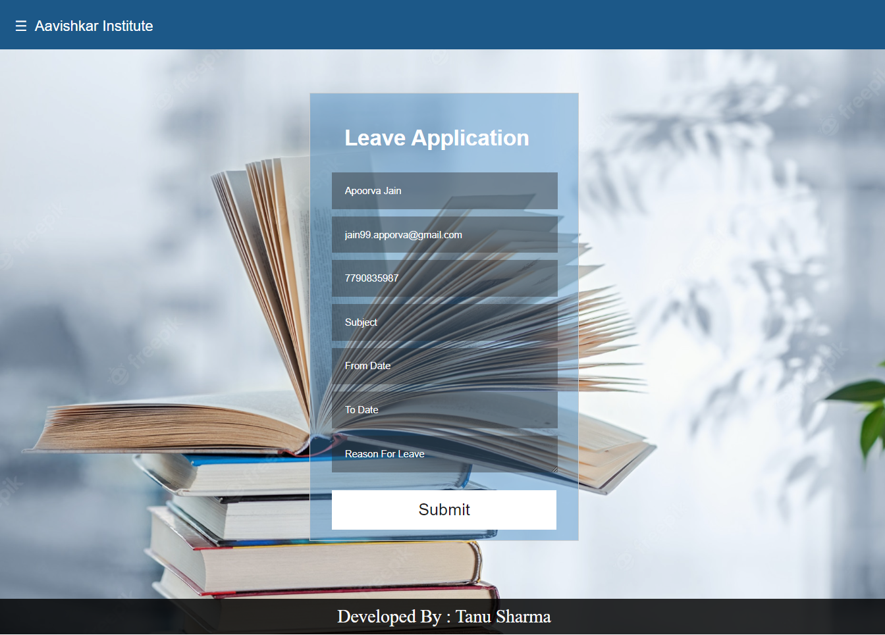

1. Feedback Page: Here user can give their feedback.

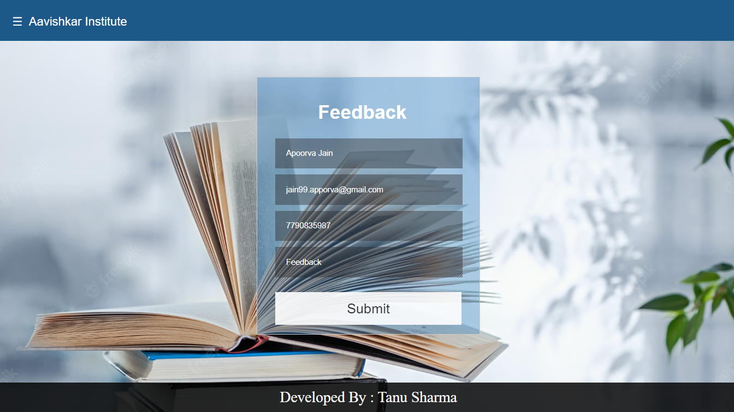

1. Profile Page: Here user can see and update his profile.

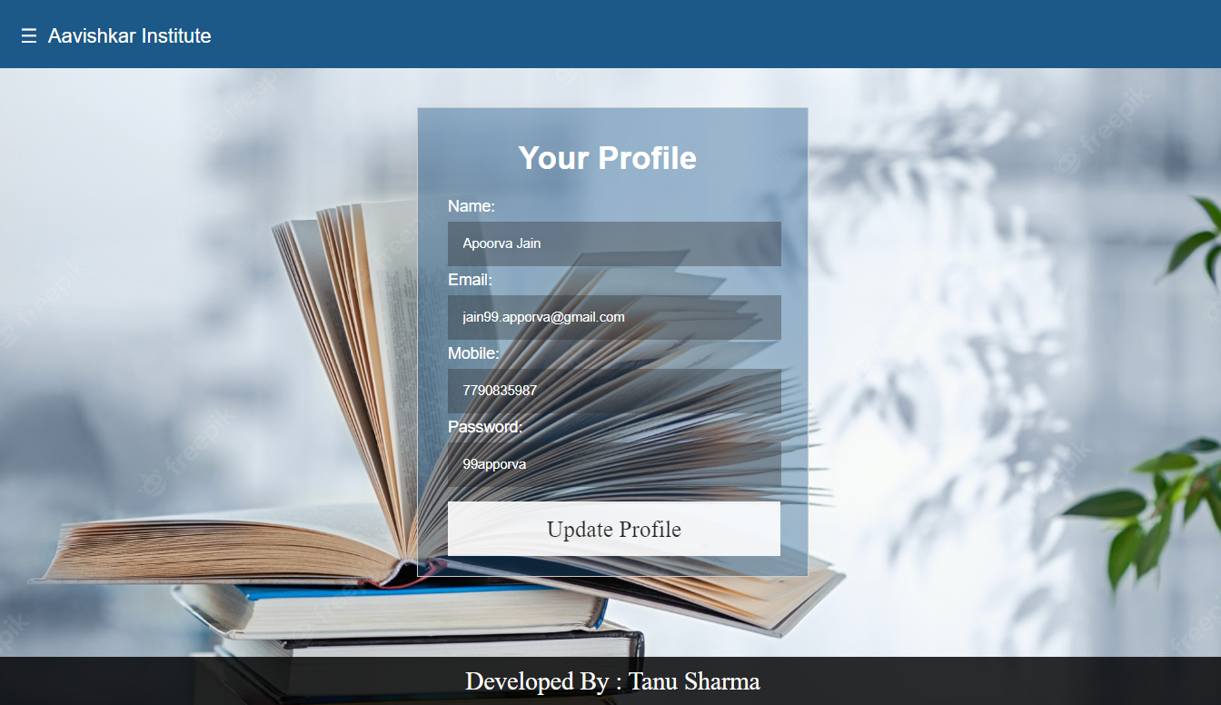

1. 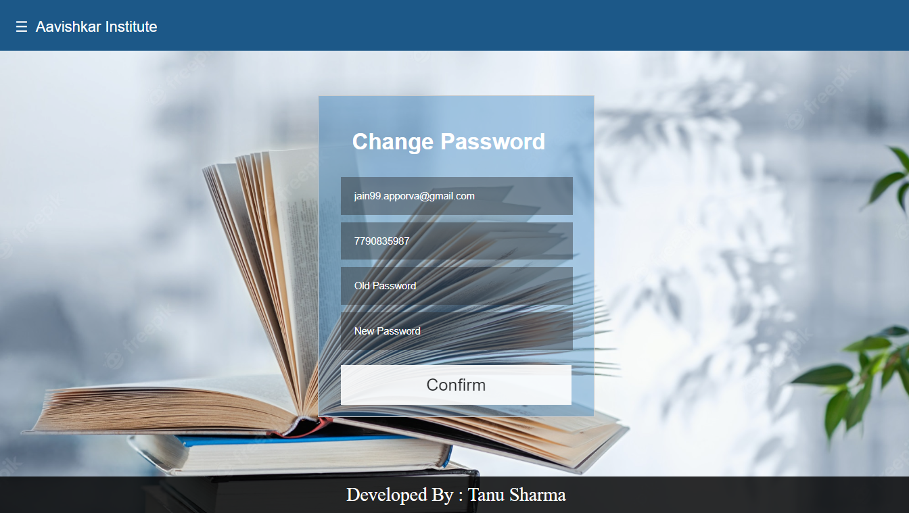Change Password Page: Here user can easily change password.

4.4 Admin Interface

1. Home Page: After admin login, a home page is displayed.



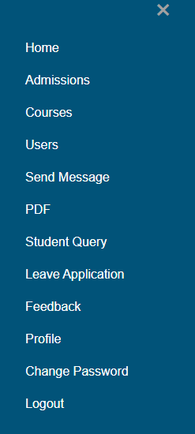On header ,there’s a menu button. Admin can open it and go to the particular page.

1. Admission Page: Here admin can add new student and confirm 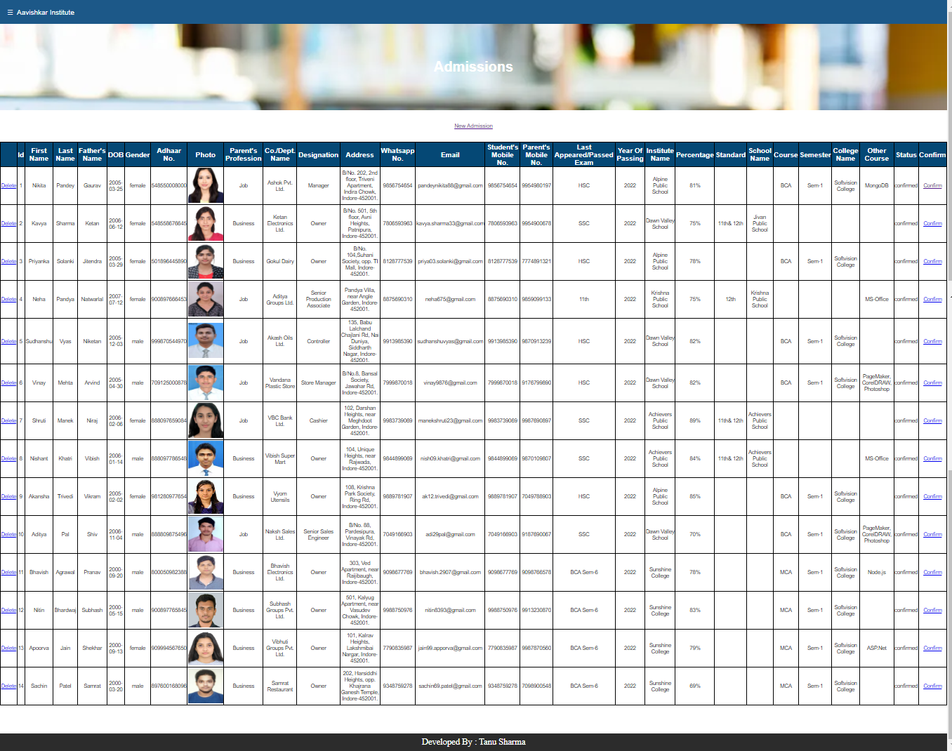or delete the admission.
2. Add New Student Page: By clicking on Add New Student an admission form is displayed where admin can add a new student.

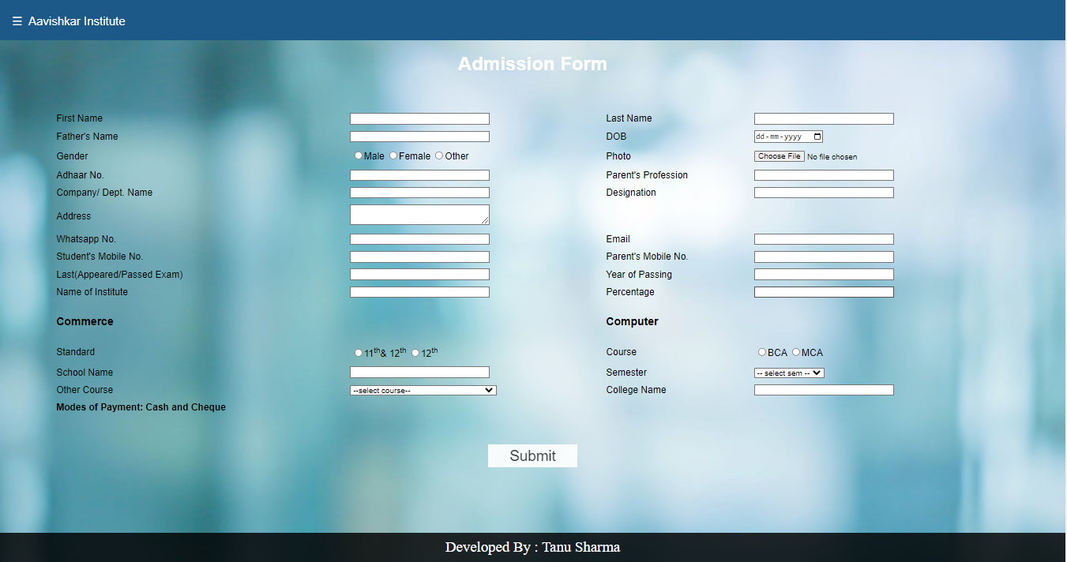

1. Courses Page: Here admin can view, add or delete courses.

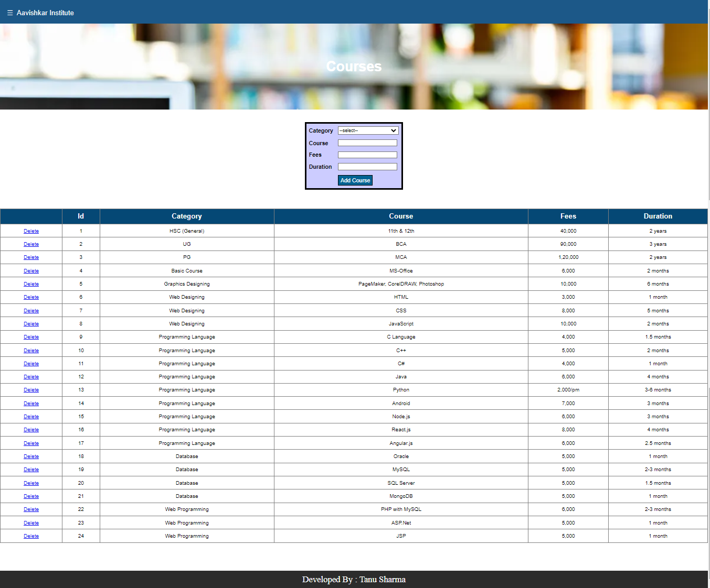

1. Users Page: Here admin can view and delete users.

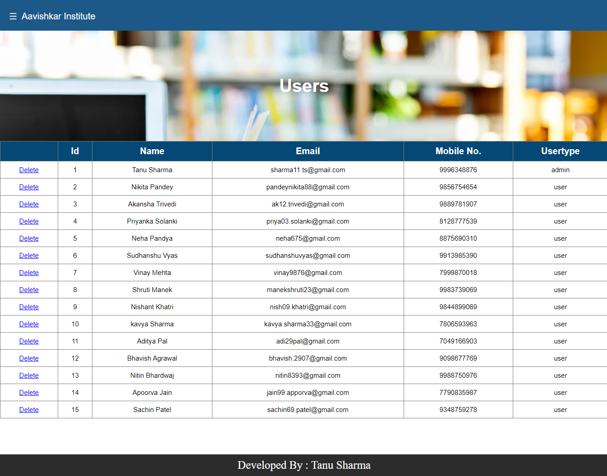

1. Messages Page: Here all messages will be displayed that are sent by admin to user and also admin can send new messages.

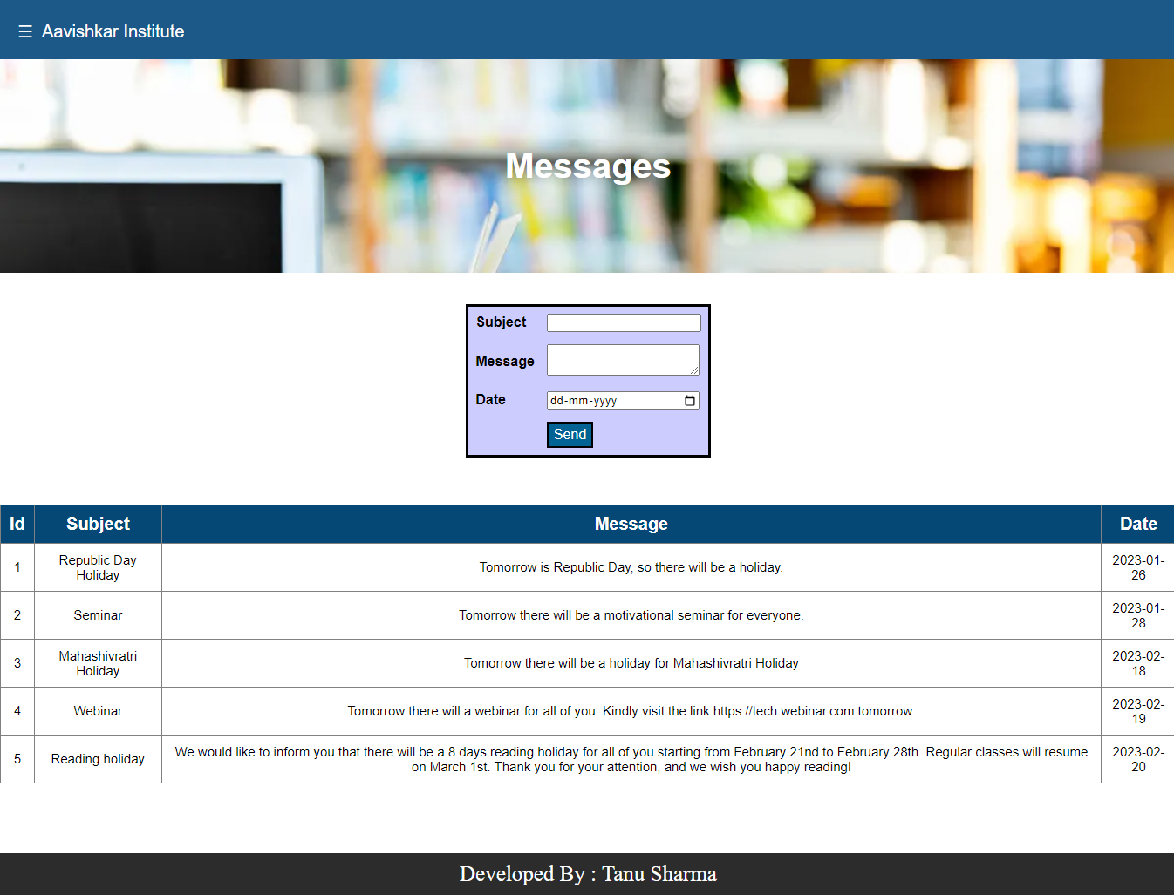

1. Student Query Page: Here admin can view queries asked by students and can also reply to them.

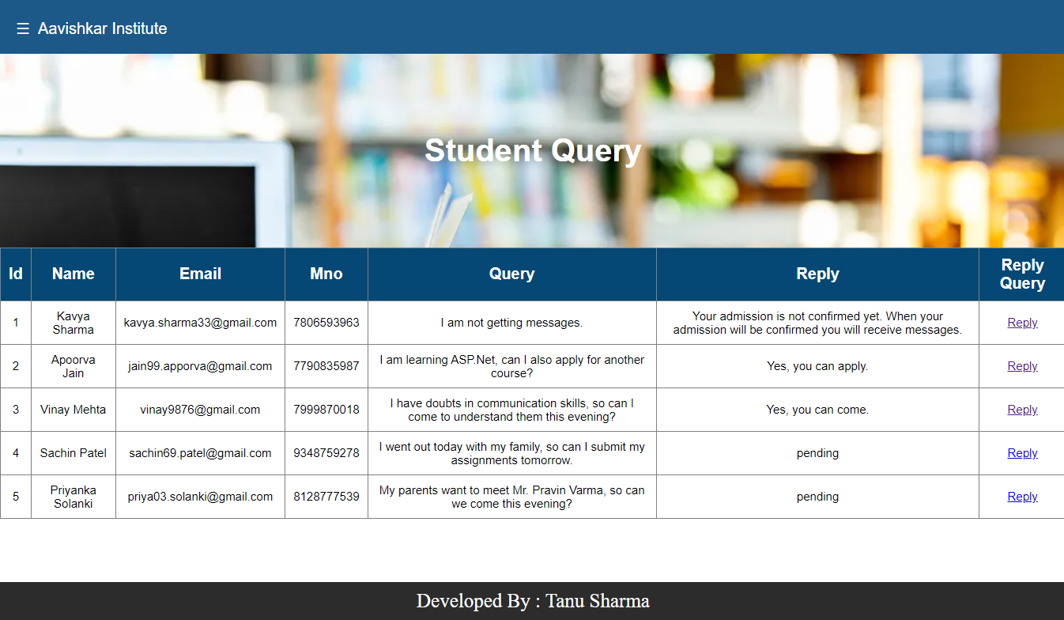

1. Reply To Student Query Page: By clicking on reply a reply to student query page is displayed where admin can reply to student’s query.

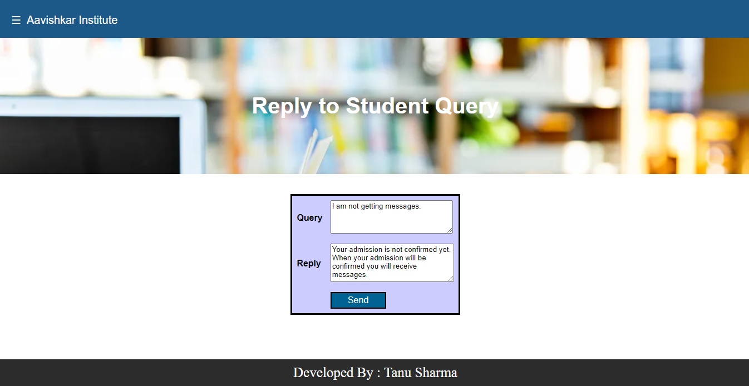

1. Leave Application Page: Here admin can view all leave applications submitted by students and can grant them.

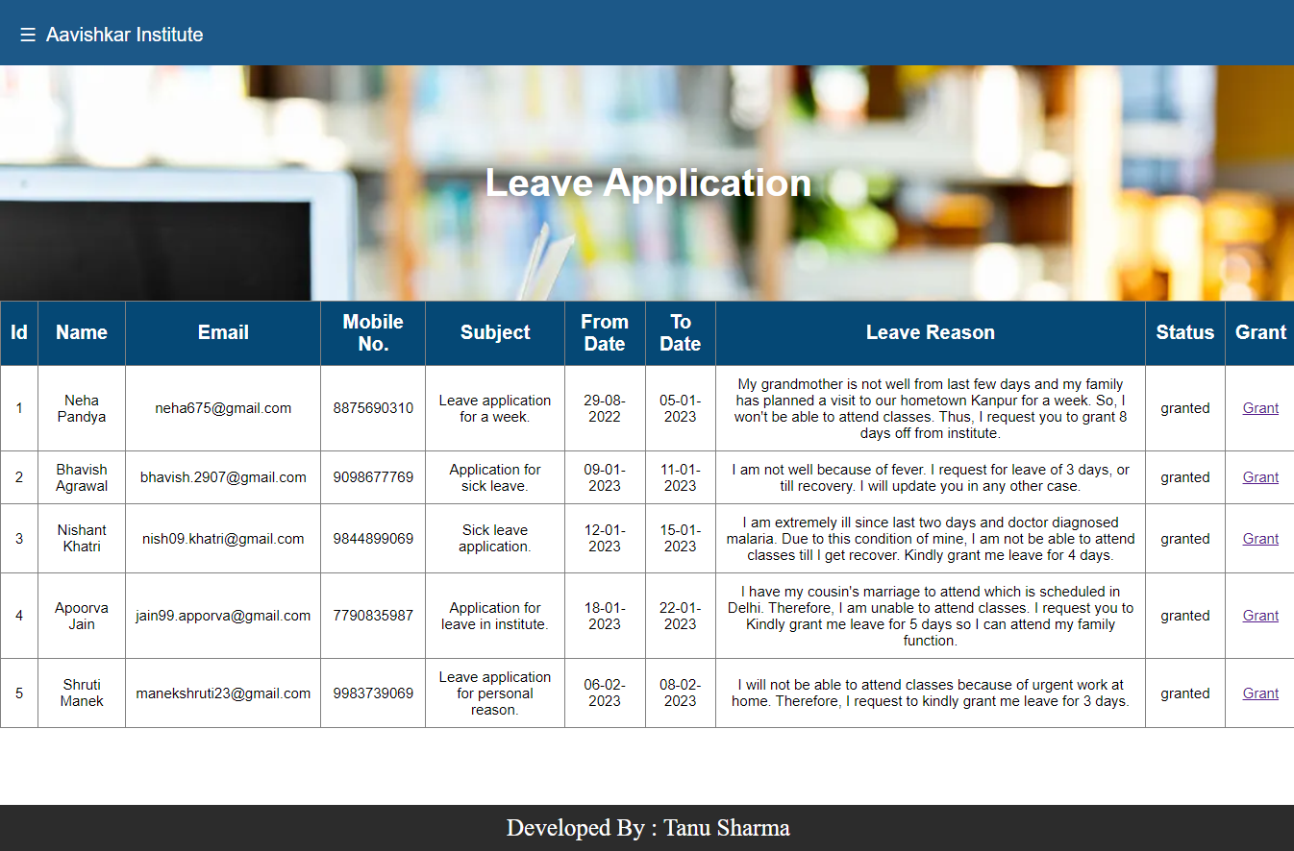

1. PDF Page: Here admin can view, delete and send pdf to students.

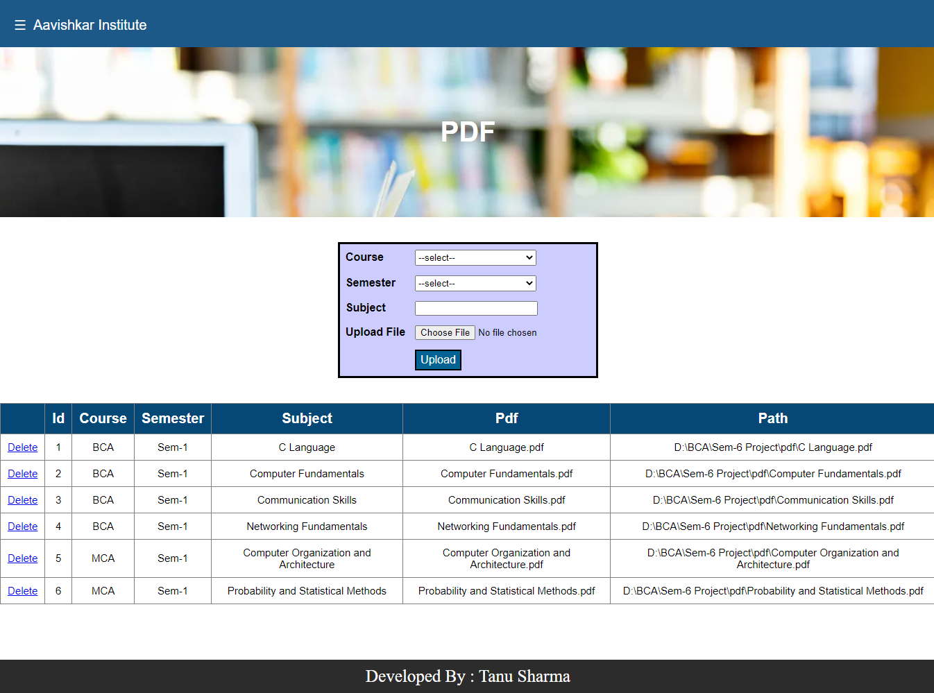

1. Feedback Page: Here admin can view and delete feedbacks.

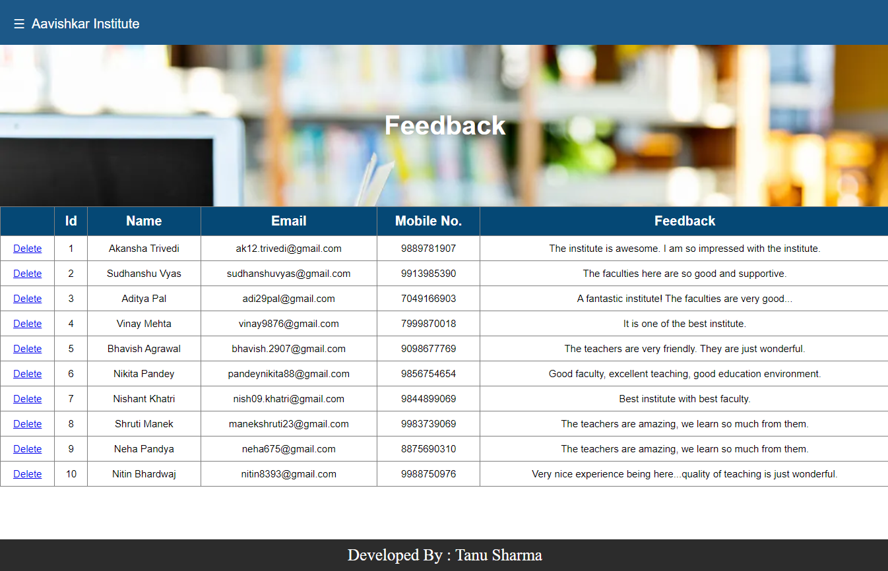

1. Profile Page: Here admin can view and update his profile.

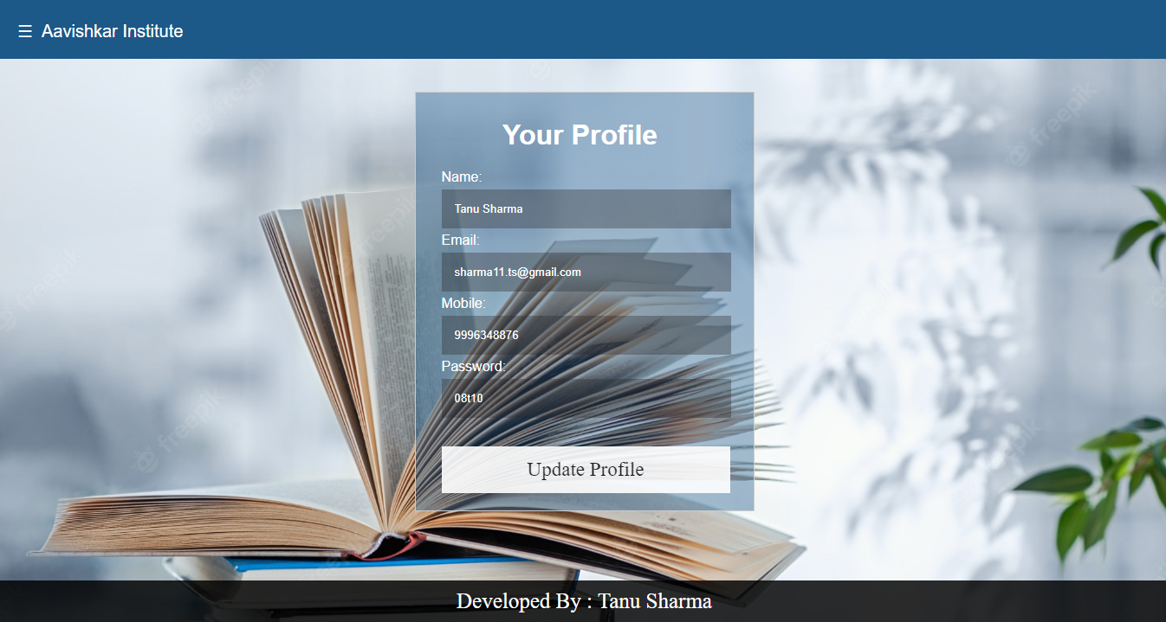

1. Change Password Page: Here admin can easily change password by providing required details.

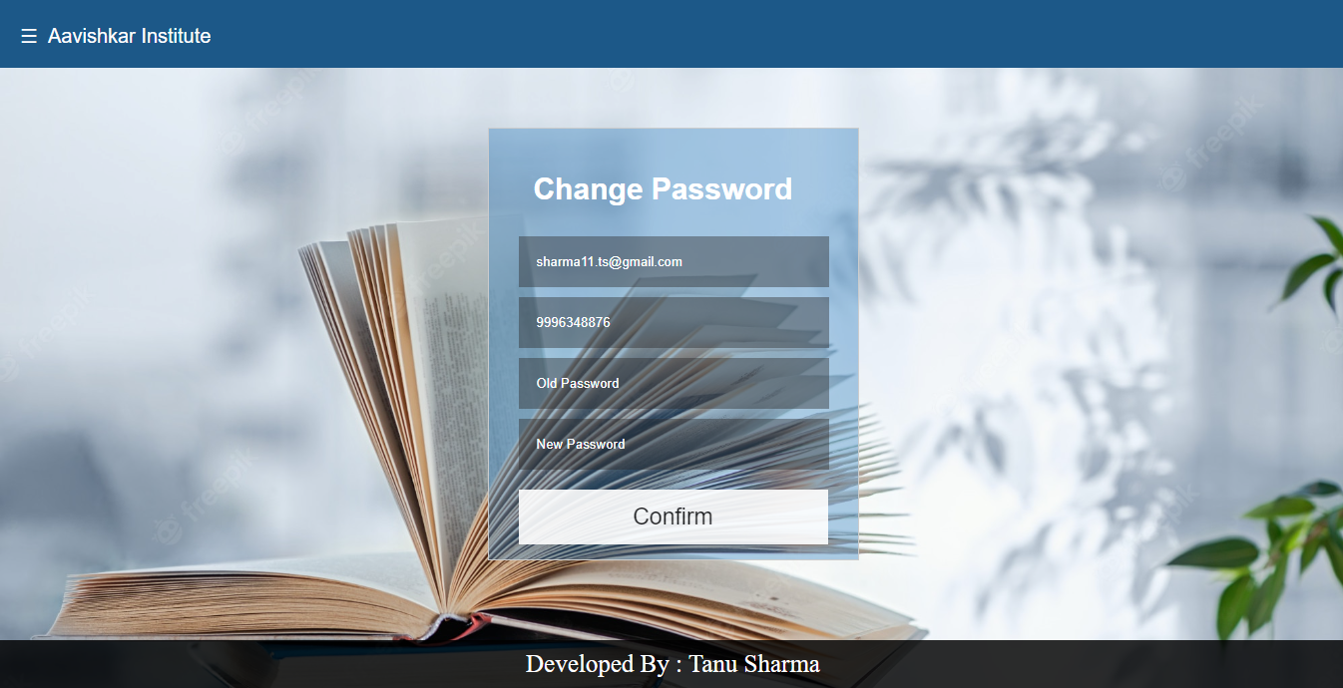

4.6 Source Code

* Visitor Side Code:
* Connection String:
* <connectionStrings>

<add name="cn" connectionString="Data Source=(LocalDB)\v11.0;AttachDbFilename='D:\BCA\Sem-6 Project\App_Data\aavishkar_institute.mdf';Integrated Security=True" providerName="System.Data.SqlClient"/>

</connectionStrings>

1. Sign Up File:

* protected void signin_Click (object sender, EventArgs e)

{

string str = WebConfigurationManager.ConnectionStrings["cn"].ToString();

string check = "select mno from user_login where email = @email or mno = @mno or password = @password";

string query = "insert into user_login (name, email, mno, password, usertype) values (@name, @email, @mno, @password, 'user')";

using (SqlConnection cn = new SqlConnection(str))

{

using (SqlCommand cmd = new SqlCommand(check, cn))

{

cmd.Parameters.AddWithValue("@email", email.Text);

cmd.Parameters.AddWithValue("@mno", mno.Text);

cmd.Parameters.AddWithValue("@password", password.Text);

cn.Open();

using (SqlDataReader dr = cmd.ExecuteReader())

{

if (dr.HasRows)

{

Response.Write("<script>alert('The user already exists')</script>");

}

else

{

dr.Close();

using (SqlCommand sqlcmd = new SqlCommand(query, cn))

{

sqlcmd.Parameters.AddWithValue("@name", name.Text);

sqlcmd.Parameters.AddWithValue("@email", email.Text);

sqlcmd.Parameters.AddWithValue("@mno", mno.Text);

sqlcmd.Parameters.AddWithValue("@password", password.Text);

sqlcmd.ExecuteNonQuery();

Response.Write("<script>alert('Registered as User...')</script>");

Response.Write("<script>setTimeout(function() { window.location.href = 'login.aspx' }, 0000);</script>");

}

}

}

cn.Close();

}

}

}

* User Side Code:

1. Login File:

* protected void login_Click(object sender, EventArgs e)

{

string str = WebConfigurationManager.ConnectionStrings["cn"].ToString();

using (SqlConnection cn = new SqlConnection(str))

{

string query = "select * from user_login where mno = @mno and password = @password";

using (SqlCommand cmd = new SqlCommand(query, cn))

{

cmd.Parameters.AddWithValue("@mno", mno.Text);

cmd.Parameters.AddWithValue("@password", password.Text);

cn.Open();

using (SqlDataReader reader = cmd.ExecuteReader())

{

if (reader.HasRows)

{

reader.Read();

if (reader["usertype"].ToString() == "admin")

{

Session["admin"] = mno.Text;

Response.Redirect("admin/Default.aspx");

}

else if (reader["usertype"].ToString() == "user")

{

Session["user"] = mno.Text;

Response.Redirect("user/Default.aspx");

}

}

else

{

Response.Write("<script>alert('Please enter a valid mobile no. or password')</script>");

}

}

cn.Close();

}

}

}

1. Forgot Password File:

* protected void confirmpswd_Click(object sender, EventArgs e)

{

string str = WebConfigurationManager.ConnectionStrings["cn"].ToString();

string mno = this.mno.Text;

string email = this.email.Text;

string password = this.password.Text;

string confirmpassword = this.confirmpassword.Text;

using (SqlConnection cn = new SqlConnection(str))

{

using (SqlCommand cmd = new SqlCommand())

{

cmd.Connection = cn;

cmd.CommandType = CommandType.Text;

cmd.CommandText = "select mno from user_login where email = @email and mno = @mno";

cmd.Parameters.AddWithValue("@email", email);

cmd.Parameters.AddWithValue("@mno", mno);

cn.Open();

SqlDataReader reader = cmd.ExecuteReader();

if (reader.HasRows)

{

reader.Close();

cmd.CommandText = "update user_login set password = @password where mno = @mno";

cmd.Parameters.AddWithValue("@password", password);

cmd.ExecuteNonQuery();

Response.Write("<script>alert('Your Password Updated Successfully...')</script>");

Response.Write("<script>setTimeout(function() { window.location.href = 'login.aspx' }, 0000);</script>");

}

else

{

Response.Write("<script>alert('Please enter a valid email or mobile no.')</script>");

}

cn.Close();

}

}

}

1. Admission File:

* protected void Page_Load(object sender, EventArgs e)

{

othercourse.DataSource = SqlDataSource1;

othercourse.DataBind();

}

protected void submit_Click(object sender, EventArgs e)

{

string str = WebConfigurationManager.ConnectionStrings["cn"].ToString();

string check = "SELECT adhaarno FROM admission WHERE adhaarno=@adhaarno";

string query = "INSERT INTO admission(fnm,lnm,fathernm,dob,gender,adhaarno,photo,parentprof,codept,designation,address,whatsappno,email,studmno,pmno,lastexam,yrofpassing,instnm,pr,std,schoolnm,course,sem,collegenm,othercourse,status) VALUES(@fnm,@lnm,@fathernm,@dob,@gender,@adhaarno,@photo,@parentprof,@codept,@designation,@address,@whatsappno,@email,@studmno,@pmno,@lastexam,@yrofpassing,@instnm,@pr,@std,@schoolnm,@course,@sem,@collegenm,@othercourse,'pending')";

using (SqlConnection cn = new SqlConnection(str))

{

using (SqlCommand sqlcmd = new SqlCommand(check, cn))

{

sqlcmd.Parameters.AddWithValue("@adhaarno", adhaarno.Text);

cn.Open();

using (SqlDataReader dr = sqlcmd.ExecuteReader())

{

if (dr.HasRows)

{

Response.Write("<script>alert('The adhaarn no. already exists')</script>");

}

else

{

dr.Close();

using (SqlCommand cmd = new SqlCommand(query, cn))

{

cmd.Parameters.AddWithValue("@fnm", fnm.Text);

cmd.Parameters.AddWithValue("@lnm", lnm.Text);

cmd.Parameters.AddWithValue("@fathernm", fathernm.Text);

cmd.Parameters.AddWithValue("@dob", dob.Text);

cmd.Parameters.AddWithValue("@gender", gender.SelectedValue);

cmd.Parameters.AddWithValue("@adhaarno", adhaarno.Text);

cmd.Parameters.AddWithValue("@photo", Path.GetFileName(photo.PostedFile.FileName));

cmd.Parameters.AddWithValue("@parentprof", parentprof.Text);

cmd.Parameters.AddWithValue("@codept", codept.Text); cmd.Parameters.AddWithValue("@designation", designation.Text);

cmd.Parameters.AddWithValue("@address", address.Text);

cmd.Parameters.AddWithValue("@whatsappno", whatsappno.Text);

cmd.Parameters.AddWithValue("@email", email.Text);

cmd.Parameters.AddWithValue("@studmno", studmno.Text);

cmd.Parameters.AddWithValue("@pmno", pmno.Text);

cmd.Parameters.AddWithValue("@lastexam", lastexam.Text);

cmd.Parameters.AddWithValue("@yrofpassing", yrofpassing.Text);

cmd.Parameters.AddWithValue("@instnm", instnm.Text);

cmd.Parameters.AddWithValue("@pr", pr.Text);

cmd.Parameters.AddWithValue("@std", std.Text);

cmd.Parameters.AddWithValue("@schoolnm", schoolnm.Text);

cmd.Parameters.AddWithValue("@course", course.SelectedValue);

cmd.Parameters.AddWithValue("@sem", sem.SelectedValue);

cmd.Parameters.AddWithValue("@collegenm", collegenm.Text);

cmd.Parameters.AddWithValue("@othercourse", othercourse.SelectedValue);

cmd.ExecuteNonQuery();

string filePath = Server.MapPath("/images/") + Path.GetFileName(photo.PostedFile.FileName);

photo.SaveAs(filePath);

Response.Write("<script>alert('Applied for admission successfully...')</script>");

Response.Write("<script>window.location='messages.aspx'</script>");

}

}

}

cn.Close();

}

}

}

}

1. Courses File:

* <asp:GridView ID="GridView1" runat="server" AutoGenerateColumns="False" DataSourceID="SqlDataSource1" CellPadding="10" Width="100%" HeaderStyle-CssClass="h" RowStyle-CssClass="r">

<Columns>

<asp:BoundField DataField="category" HeaderText="Category" SortExpression="category" />

<asp:BoundField DataField="course" HeaderText="Course" SortExpression="course" />

<asp:BoundField DataField="fees" HeaderText="Fees" SortExpression="fees" />

<asp:BoundField DataField="duration" HeaderText="Duration" SortExpression="duration" />

</Columns>

</asp:GridView>

<asp:SqlDataSource ID="SqlDataSource1" runat="server" ConnectionString="<%$ ConnectionStrings:cn %>" SelectCommand="SELECT [category], [course], [fees], [duration] FROM [courses]"></asp:SqlDataSource>

1. Messages File:

* <div>

<h1>Messages</h1>

<div class="container">

<asp:Repeater ID="admission" runat="server" DataSourceID="SqlDataSource4">

<ItemTemplate>

<%#Eval("fnm") %>

<%#Eval("fathernm") %>

<%#Eval("lnm") %>

your admission is <%#Eval("status") %>

</ItemTemplate>

</asp:Repeater>

<asp:SqlDataSource ID="SqlDataSource4" runat="server" ConnectionString="<%$ ConnectionStrings:cn %>" SelectCommand="SELECT [fnm], [lnm], [fathernm], [status] FROM [admission] WHERE (([pmno] = @mno) OR ([studmno] = @mno))">

<SelectParameters>

<asp:SessionParameter Name="mno" SessionField="user" Type="String" />

</SelectParameters>

</asp:SqlDataSource>

</div>

<div class="container">

<asp:Repeater ID="studquery" runat="server" DataSourceID="SqlDataSource3">

<ItemTemplate>

Your Query: <%#Eval("query") %><br />

Answer:<%#Eval("reply") %><br />

</ItemTemplate>

</asp:Repeater>

<asp:SqlDataSource ID="SqlDataSource3" runat="server" ConnectionString="<%$ ConnectionStrings:cn %>" SelectCommand="SELECT [query], [reply] FROM [studquery] WHERE ([mno] = @mno)">

<SelectParameters>

<asp:SessionParameter Name="mno" SessionField="user" Type="String" />

</SelectParameters>

</asp:SqlDataSource>

</div>

<div class="container">

<asp:Repeater ID="lvapp" runat="server" DataSourceID="SqlDataSource1">

<ItemTemplate>

<%# Eval("name") %> Your Leave is <%# Eval("status") %>.

</ItemTemplate>

</asp:Repeater>

<asp:SqlDataSource ID="SqlDataSource1" runat="server" ConnectionString="<%$ ConnectionStrings:cn %>" SelectCommand="SELECT [name], [status] FROM [lv_app] WHERE ([mno] = @mno)">

<SelectParameters>

<asp:SessionParameter Name="mno" SessionField="user" Type="String" />

</SelectParameters>

</asp:SqlDataSource>

</div>

<div class="container">

<asp:Repeater ID="message" runat="server" DataSourceID="SqlDataSource2">

<ItemTemplate>

<b>Date:</b> <%#Eval("Date") %><br />

<b>Subject:</b> <%#Eval("subject") %><br />

<b>Message:</b> <%#Eval("message") %><br />

<br /><br />

</ItemTemplate>

</asp:Repeater>

<asp:SqlDataSource ID="SqlDataSource2" runat="server" ConnectionString="<%$ ConnectionStrings:cn %>" SelectCommand="SELECT [date], [subject], [message] FROM [messages]"></asp:SqlDataSource>

</div>

<div class="container">

<asp:Repeater ID="pdf" runat="server" DataSourceID="SqlDataSource5">

<ItemTemplate>

<b>Course:</b> <%#Eval("course") %><br />

<b>Semester:</b> <%#Eval("sem") %><br />

<b>Subject:</b> <%#Eval("subject") %><br />

<asp:Label ID="pdf1" runat="server" Text="PDF: " Font-Bold="True" Font- Size="Medium"></asp:Label>

<asp:Label ID="pdf" runat="server" Text='<%#Eval("pdf") %>' ReadOnly="True" Font-Names="Arial" Font-Size="Medium"></asp:Label>

<br /><asp:Button ID="Button1" runat="server" Text="Click To Download" OnClick="btnDownload_Click" BackColor="#003366" ForeColor="White" Height="25" BorderColor="White" Font- Size="Medium" style="margin-top:5px;" /><br /><br />

</ItemTemplate>

</asp:Repeater>

<asp:SqlDataSource ID="SqlDataSource5" runat="server" ConnectionString="<%$ ConnectionStrings:cn %>" SelectCommand="SELECT [course], [sem], [subject], [pdf] FROM [pdf]"></asp:SqlDataSource>

</div>

</div>

* protected void btnDownload_Click(object sender, EventArgs e)

{

Button button = (Button)sender;

RepeaterItem item = (RepeaterItem)button.NamingContainer;

Label pdf = (Label)item.FindControl("pdf");

string fileName = pdf.Text;

string connectionString = WebConfigurationManager.ConnectionStrings["cn"].ConnectionString;

string query = "SELECT path FROM pdf WHERE pdf = @pdf";

using (SqlConnection conn = new SqlConnection(connectionString))

{

using (SqlCommand cmd = new SqlCommand(query, conn))

{

cmd.Parameters.AddWithValue("@pdf", fileName);

conn.Open();

object result = cmd.ExecuteScalar();

if (result != null)

{

string filePath = result.ToString();

Response.ContentType = "application/pdf";

Response.AppendHeader("Content- Disposition", "attachment; filename=" + fileName);

Response.TransmitFile(filePath);

Response.End();

}

Response.Redirect(Request.Url.AbsoluteUri);

}

}

}

1. Student Query File:

* protected void submit_Click(object sender, EventArgs e)

{

string cn = WebConfigurationManager.ConnectionStrings["cn"].ToString();

using (SqlConnection connection = new SqlConnection(cn))

{

connection.Open();

string q = "INSERT INTO studquery (name,email,mno,query,reply) VALUES (@name,@email,@mno,@query,'')";

using (SqlCommand command = new SqlCommand(q, connection))

{

command.Parameters.AddWithValue("@name", ((TextBox)r1.Items[0].FindControl("name")).Text);

command.Parameters.AddWithValue("@email", ((TextBox)r1.Items[0].FindControl("email")).Text);

command.Parameters.AddWithValue("@mno", ((TextBox)r1.Items[0].FindControl("mno")).Text);

command.Parameters.AddWithValue("@query", query.Text);

command.ExecuteNonQuery();

}

Response.Write("<script>alert('Query Sent...')</script>");

}

Response.Redirect(Request.Url.AbsoluteUri);

}

1. Leave Application File:

* protected void submit_Click(object sender, EventArgs e)

{

string cn = WebConfigurationManager.ConnectionStrings["cn"].ToString();

using (SqlConnection connection = new SqlConnection(cn))

{

connection.Open();

string query = "INSERT INTO lv_app (name,email,mno,subject,from_dt,to_dt,lv_reason,status) VALUES (@name,@email,@mno,@subject,@from_dt,@to_dt,@lv_reason,'')";

using (SqlCommand command = new SqlCommand(query, connection))

{

command.Parameters.AddWithValue("@name", ((TextBox)r1.Items[0].FindControl("name")).Text);

command.Parameters.AddWithValue("@email", ((TextBox)r1.Items[0].FindControl("email")).Text);

command.Parameters.AddWithValue("@mno", ((TextBox)r1.Items[0].FindControl("mno")).Text);

command.Parameters.AddWithValue("@subject", subject.Text);

command.Parameters.AddWithValue("@from_dt", from_dt.Text);

command.Parameters.AddWithValue("@to_dt", to_dt.Text);

command.Parameters.AddWithValue("@lv_reason", lv_reason.Text);

command.ExecuteNonQuery();

}

Response.Write("<script>alert('Applied For Leave...')</script>");

}

Response.Redirect(Request.Url.AbsoluteUri);

}

1. Feedback File:

* protected void submit_Click(object sender, EventArgs e)

{

string cn = WebConfigurationManager.ConnectionStrings["cn"].ToString();

using (SqlConnection connection = new SqlConnection(cn))

{

connection.Open();

string query = "INSERT INTO feedback (name,email,mno,feedback) VALUES (@name,@email,@mno,@feedback)";

using (SqlCommand command = new SqlCommand(query, connection))

{

command.Parameters.AddWithValue("@name", ((TextBox)r1.Items[0].FindControl("name")).Text);

command.Parameters.AddWithValue("@email", ((TextBox)r1.Items[0].FindControl("email")).Text);

command.Parameters.AddWithValue("@mno", ((TextBox)r1.Items[0].FindControl("mno")).Text);

command.Parameters.AddWithValue("@feedback", feedback.Text.Trim());

command.ExecuteNonQuery();

}

Response.Write("<script>alert('Thank you for your feedback...')</script>");

}

Response.Redirect(Request.Url.AbsoluteUri);

}

1. Profile File:

* protected void upd_Click(object sender, EventArgs e)

{

string str = WebConfigurationManager.ConnectionStrings["cn"].ToString();

string name = ((TextBox)profile.Items[0].FindControl("name")).Text;

string email = ((TextBox)profile.Items[0].FindControl("email")).Text;

string query = "UPDATE user_login SET name=@name, email=@email WHERE mno=@mno";

using (SqlConnection cn = new SqlConnection(str))

{

using (SqlCommand cmd = new SqlCommand(query, cn))

{

cmd.Parameters.AddWithValue("@name", name);

cmd.Parameters.AddWithValue("@email", email);

cmd.Parameters.AddWithValue("@mno", Session["user"].ToString());

cn.Open();

cmd.ExecuteNonQuery();

cn.Close();

}

}

Response.Write("<script>alert('Profile Updated Successfully....')</script>");

profile.DataBind();

}

1. Change Password File:

* protected void confirm_Click(object sender, EventArgs e)

{

string str = WebConfigurationManager.ConnectionStrings["cn"].ToString();

string confirmpassword = this.newpassword.Text;

using (SqlConnection cn = new SqlConnection(str))

{

using (SqlCommand cmd = new SqlCommand())

{

cmd.Connection = cn;

cmd.CommandType = CommandType.Text;

cn.Open();

SqlDataReader reader = cmd.ExecuteReader();

if (reader.HasRows)

{

reader.Close();

using (SqlCommand cmd2 = new SqlCommand())

{

cmd2.Connection = cn;

cmd2.CommandType = CommandType.Text;

cmd2.CommandText = "update user_login set password = @newpassword where mno = @mno";

cmd2.Parameters.AddWithValue("@newpassword", this.newpassword.Text);

cmd2.ExecuteNonQuery();

}

Response.Write("<script>alert('Your Password Updated Successfully...')</script>");

}

else

{

Response.Write("<script>alert('Please enter a valid email or mobile no. or password')</script>");

}

cn.Close();

}

}}

1. Logout File:

* protected void Page_Load(object sender, EventArgs e)

{

Session.Clear();

Session.Abandon();

Session.RemoveAll();

Response.Redirect("~/Login.aspx");

}

* Admin Side Code:

1. Admission List File:

* <center><a href="newadmission.aspx">New Admission</a><br /><br /></center><br />

<asp:GridView ID="GridView1" runat="server" AutoGenerateColumns="False" DataKeyNames="Id" DataSourceID="SqlDataSource1" HeaderStyle-CssClass="h" RowStyle-CssClass="r" BorderStyle="Solid" BorderColor="Black" AutoGenerateDeleteButton="True">

<Columns>

<asp:BoundField DataField="Id" HeaderText="Id" InsertVisible="False" ReadOnly="True" SortExpression="Id" />

<asp:BoundField DataField="fnm" HeaderText="First Name" SortExpression="fnm" />

<asp:BoundField DataField="lnm" HeaderText="Last Name" SortExpression="lnm" />

<asp:BoundField DataField="fathernm" HeaderText="Father's Name" SortExpression="fathernm" />

<asp:BoundField DataField="dob" HeaderText="DOB" SortExpression="dob" />

<asp:BoundField DataField="gender" HeaderText="Gender" SortExpression="gender" />

<asp:BoundField DataField="adhaarno" HeaderText="Adhaar No." SortExpression="adhaarno" />

<asp:TemplateField HeaderText="Photo">

<ItemTemplate>

<asp:Image ID="photo" runat="server" ImageUrl='<%# "/images/" + Eval("photo") %>' />

</ItemTemplate>

<ControlStyle Height="100px" Width="100px" />

</asp:TemplateField>

<asp:BoundField DataField="parentprof" HeaderText="Parent's Profession" SortExpression="parentprof" />

<asp:BoundField DataField="codept" HeaderText="Co./Dept. Name" SortExpression="codept" />

<asp:BoundField DataField="designation" HeaderText="Designation" SortExpression="designation" />

<asp:BoundField DataField="address" HeaderText="Address" SortExpression="address" />

<asp:BoundField DataField="whatsappno" HeaderText="Whatsapp No." SortExpression="whatsappno" />

<asp:BoundField DataField="email" HeaderText="Email" SortExpression="email" />

<asp:BoundField DataField="studmno" HeaderText="Student's Mobile No." SortExpression="studmno" />

<asp:BoundField DataField="pmno" HeaderText="Parent's Mobile No." SortExpression="pmno" />

<asp:BoundField DataField="lastexam" HeaderText="Last Appeared/Passed Exam" SortExpression="lastexam" />

<asp:BoundField DataField="yrofpassing" HeaderText="Year Of Passing" SortExpression="yrofpassing" />

<asp:BoundField DataField="instnm" HeaderText="Institute Name" SortExpression="instnm" />

<asp:BoundField DataField="pr" HeaderText="Percentage" SortExpression="pr" />

<asp:BoundField DataField="std" HeaderText="Standard" SortExpression="std" />

<asp:BoundField DataField="schoolnm" HeaderText="School Name" SortExpression="schoolnm" />

<asp:BoundField DataField="course" HeaderText="Course" SortExpression="course" />

<asp:BoundField DataField="sem" HeaderText="Semester" SortExpression="sem" />

<asp:BoundField DataField="collegenm" HeaderText="College Name" SortExpression="collegenm" />

<asp:BoundField DataField="othercourse" HeaderText="Other Course" SortExpression="othercourse" />

<asp:BoundField DataField="status" HeaderText="Status" SortExpression="status" />

<asp:HyperLinkField HeaderText="Confirm" Text="Confirm" DataNavigateUrlFields="id" DataNavigateUrlFormatString="confirmad.aspx?id={0}" />

</Columns>

<HeaderStyle CssClass="h"></HeaderStyle>

<RowStyle CssClass="r"></RowStyle>

</asp:GridView>

<asp:SqlDataSource ID="SqlDataSource1" runat="server" ConnectionString="<%$ ConnectionStrings:cn %>" SelectCommand="SELECT * FROM [admission]" DeleteCommand="DELETE FROM [admission] WHERE [id] = @id"></asp:SqlDataSource>

1. Confirm Admission File:

* protected void Page_Load(object sender, EventArgs e)

{

if (!IsPostBack)

{

int id = Convert.ToInt32(Request.QueryString["id"]);

string connectionString = WebConfigurationManager.ConnectionStrings["cn"].ConnectionString;

using (SqlConnection cn = new SqlConnection(connectionString))

{

cn.Open();

SqlCommand cmd = new SqlCommand("update admission set status='confirmed' where id=@id", cn);

cmd.Parameters.AddWithValue("@id", id);

cmd.ExecuteNonQuery();

}

Response.Write("<script> alert('Admission Confirmed')</script>");

Response.Write("<script>window.location='admissions.aspx'</script>");

}

}

1. New Admission File:

* protected void Page_Load(object sender, EventArgs e)

{

othercourse.DataSource = SqlDataSource1;

othercourse.DataBind();

}

protected void submit_Click(object sender, EventArgs e)

{

string str = WebConfigurationManager.ConnectionStrings["cn"].ToString();

string check = "SELECT adhaarno FROM admission WHERE adhaarno=@adhaarno";

string query = "INSERT INTO admission(fnm,lnm,fathernm,dob,gender,adhaarno,photo,parentprof,codept,designation,address,whatsappno,email,studmno,pmno,lastexam,yrofpassing,instnm,pr,std,schoolnm,course,sem,collegenm,othercourse,status) VALUES(@fnm,@lnm,@fathernm,@dob,@gender,@adhaarno,@photo,@parentprof,@codept,@designation,@address,@whatsappno,@email,@studmno,@pmno,@lastexam,@yrofpassing,@instnm,@pr,@std,@schoolnm,@course,@sem,@collegenm,@othercourse,'pending')";

using (SqlConnection cn = new SqlConnection(str))

{

using (SqlCommand sqlcmd = new SqlCommand(check, cn))

{

sqlcmd.Parameters.AddWithValue("@adhaarno", adhaarno.Text);

cn.Open();

using (SqlDataReader dr = sqlcmd.ExecuteReader())

{

if (dr.HasRows)

{

Response.Write("<script>alert('The adhaarn no. already exists')</script>");

}

else

{

dr.Close();

using (SqlCommand cmd = new SqlCommand(query, cn))

{

cmd.Parameters.AddWithValue("@fnm", fnm.Text);

cmd.Parameters.AddWithValue("@lnm", lnm.Text);

cmd.Parameters.AddWithValue("@fathernm", fathernm.Text);

cmd.Parameters.AddWithValue("@dob", dob.Text);

cmd.Parameters.AddWithValue("@gender", gender.SelectedValue);

cmd.Parameters.AddWithValue("@adhaarno", adhaarno.Text);

cmd.Parameters.AddWithValue("@photo", Path.GetFileName(photo.PostedFile.FileName));

cmd.Parameters.AddWithValue("@parentprof", parentprof.Text);

cmd.Parameters.AddWithValue("@codept", codept.Text); cmd.Parameters.AddWithValue("@designation", designation.Text);

cmd.Parameters.AddWithValue("@address", address.Text);

cmd.Parameters.AddWithValue("@whatsappno", whatsappno.Text);

cmd.Parameters.AddWithValue("@email", email.Text);

cmd.Parameters.AddWithValue("@studmno", studmno.Text);

cmd.Parameters.AddWithValue("@pmno", pmno.Text);

cmd.Parameters.AddWithValue("@lastexam", lastexam.Text);

cmd.Parameters.AddWithValue("@yrofpassing", yrofpassing.Text);

cmd.Parameters.AddWithValue("@instnm", instnm.Text);

cmd.Parameters.AddWithValue("@pr", pr.Text);

cmd.Parameters.AddWithValue("@std", std.Text);

cmd.Parameters.AddWithValue("@schoolnm", schoolnm.Text);

cmd.Parameters.AddWithValue("@course", course.SelectedValue);

cmd.Parameters.AddWithValue("@sem", sem.SelectedValue);

cmd.Parameters.AddWithValue("@collegenm

", collegenm.Text);

cmd.Parameters.AddWithValue("@othercourse", othercourse.SelectedValue);

cmd.ExecuteNonQuery();

string filePath = Server.MapPath("/images/") + Path.GetFileName(photo.PostedFile.FileName);

photo.SaveAs(filePath);

Response.Write("<script>alert('Applied for admission successfully...')</script>");

Response.Write("<script>window.location='messages.aspx'</script>");

}

}

}

cn.Close();

}

}

}

}

1. Courses File:

* protected void add_Click(object sender, EventArgs e)

{

if (category.Text.Trim() != "" && course.Text.Trim() != "" && fees.Text.Trim() != "" && duration.Text.Trim() != "")

{

string connectionString = WebConfigurationManager.ConnectionStrings["cn"].ToString();

using (SqlConnection connection = new SqlConnection(connectionString))

{

connection.Open();

string query = "INSERT INTO courses (category, course, fees, duration) VALUES (@category, @course, @fees, @duration)";

using (SqlCommand command = new SqlCommand(query, connection))

{

command.Parameters.AddWithValue("@category", category.Text.Trim());

command.Parameters.AddWithValue("@course", course.Text.Trim());

command.Parameters.AddWithValue("@fees", fees.Text.Trim());

command.Parameters.AddWithValue("@duration", duration.Text.Trim());

command.ExecuteNonQuery();

}

Response.Write("<script>alert('Course Added Successfully...')</script>");

}

Response.Redirect(Request.Url.AbsoluteUri);

}

else

{

Response.Write("<script>alert('Please fill in all fields')</script>");

}

}

1. Users File:

* <asp:GridView ID="GridView1" runat="server" AutoGenerateColumns="False" DataSourceID="SqlDataSource1" CellPadding="10" Width="100%" AutoGenerateDeleteButton="True" DataKeyNames="mno" HeaderStyle-CssClass="h" RowStyle-CssClass="r">

<Columns>

<asp:BoundField DataField="id" HeaderText="Id" SortExpression="id" />

<asp:BoundField DataField="name" HeaderText="Name" SortExpression="name" />

<asp:BoundField DataField="email" HeaderText="Email" SortExpression="email" />

<asp:BoundField DataField="mno" HeaderText="Mobile No." SortExpression="mobile" />

<asp:BoundField DataField="usertype" HeaderText="Usertype" SortExpression="usertype" />

</Columns>

<HeaderStyle CssClass="h"></HeaderStyle>

<RowStyle CssClass="r"></RowStyle>

</asp:GridView>

<asp:SqlDataSource ID="SqlDataSource1" runat="server" ConnectionString="<%$ ConnectionStrings:cn %>" SelectCommand="SELECT [id], [name], [email], [mno], [usertype] FROM [user_login]" DeleteCommand="DELETE FROM [user_login] WHERE [mno] = @mno"></asp:SqlDataSource>

1. Messages File:

* protected void send_Click(object sender, EventArgs e)

{

if (subject.Text.Trim() != "" && message.Text.Trim() != "" && date.Text.Trim() != "")

{

string connectionString = WebConfigurationManager.ConnectionStrings["cn"].ToString();

using (SqlConnection connection = new SqlConnection(connectionString))

{

connection.Open();

string query = "INSERT INTO messages(subject, message, date) VALUES (@subject, @message, @date)";

using (SqlCommand command = new SqlCommand(query, connection))

{

command.Parameters.AddWithValue("@subject", subject.Text.Trim());

command.Parameters.AddWithValue("@message", message.Text.Trim());

command.Parameters.AddWithValue("@date", date.Text.Trim());

command.ExecuteNonQuery();

Response.Write("<script>alert('Messsage Sent Successfully...')</script>");

}

}

Response.Redirect(Request.Url.AbsoluteUri);

}

else

{

Response.Write("<script>alert('Please fill in all fields')</script>");

}

}

1. Student Query File:

* <asp:GridView ID="GridView1" runat="server" AutoGenerateColumns="False" DataKeyNames="Id" DataSourceID="SqlDataSource1" CellPadding="10" Width="100%" HeaderStyle-CssClass="h" RowStyle-CssClass="r">

<Columns>

<asp:BoundField DataField="Id" HeaderText="Id" InsertVisible="False" ReadOnly="True" SortExpression="Id" />

<asp:BoundField DataField="name" HeaderText="Name" SortExpression="name" />

<asp:BoundField DataField="email" HeaderText="Email" SortExpression="email" />

<asp:BoundField DataField="mno" HeaderText="Mno" SortExpression="mno" />

<asp:BoundField DataField="query" HeaderText="Query" SortExpression="query" />

<asp:BoundField DataField="reply" HeaderText="Reply" SortExpression="reply" />

<asp:HyperLinkField HeaderText="Reply Query" Text="Reply" DataNavigateUrlFields="id" DataNavigateUrlFormatString="replyquery.aspx?id={0}" />

</Columns>

</asp:GridView>

<asp:SqlDataSource ID="SqlDataSource1" runat="server" ConnectionString="<%$ ConnectionStrings:cn %>" SelectCommand="SELECT * FROM [studquery]">

</asp:SqlDataSource>

1. Reply Student Query File:

* protected void Page_Load(object sender, EventArgs e)

{

if (!IsPostBack)

{

if (Request.QueryString["id"] != null)

{

int id = Convert.ToInt32(Request.QueryString["id"]);

LoadData(id);

this.id.Value = id.ToString();

}

}

}

protected void LoadData(int id)

{

string connectionString = WebConfigurationManager.ConnectionStrings["cn"].ConnectionString;

string query = "select * from studquery where id=@id";

using (SqlConnection connection = new SqlConnection(connectionString))

{

SqlCommand command = new SqlCommand(query, connection);

command.Parameters.AddWithValue("@id", id);

connection.Open();

SqlDataReader reader = command.ExecuteReader();

if (reader.Read())

{

Query.Text = reader["query"].ToString();

Reply.Text = reader["reply"].ToString();

}

reader.Close();

}

}

protected void send_Click(object sender, EventArgs e)

{

int id = Convert.ToInt32(this.id.Value);

string reply = Reply.Text.Trim();

string connectionString = WebConfigurationManager.ConnectionStrings["cn"].ConnectionString;

string query = "update studquery set reply=@reply where id=@id";

using (SqlConnection connection = new SqlConnection(connectionString))

{

SqlCommand command = new SqlCommand(query, connection);

command.Parameters.AddWithValue("@reply", reply);

command.Parameters.AddWithValue("@id", id);

connection.Open();

command.ExecuteNonQuery();

}

Response.Write("<script> alert('Reply Sent Successfully')</script>");

Response.Write("<script>window.location='studquery.aspx'</script>");

}

1. Leave Application File:

* <asp:GridView ID="GridView1" runat="server" AutoGenerateColumns="False" DataKeyNames="Id" DataSourceID="SqlDataSource1" CellPadding="10" Width="100%" HeaderStyle-CssClass="h" RowStyle-CssClass="r">

<Columns>

<asp:BoundField DataField="Id" HeaderText="Id" InsertVisible="False" ReadOnly="True" SortExpression="Id" />

<asp:BoundField DataField="name" HeaderText="Name" SortExpression="name" />

<asp:BoundField DataField="email" HeaderText="Email" SortExpression="email" />

<asp:BoundField DataField="mno" HeaderText="Mobile No." SortExpression="mno" />

<asp:BoundField DataField="subject" HeaderText="Subject" SortExpression="subject" />

<asp:BoundField DataField="from_dt" HeaderText="From Date" SortExpression="from_dt" />

<asp:BoundField DataField="to_dt" HeaderText="To Date" SortExpression="to_dt" />

<asp:BoundField DataField="lv_reason" HeaderText="Leave Reason" SortExpression="lv_reason" />

<asp:BoundField DataField="status" HeaderText="Status" SortExpression="status" />

<asp:HyperLinkField HeaderText="Grant" Text="Grant" DataNavigateUrlFields="id" DataNavigateUrlFormatString="grantlv.aspx?id={0}" />

</Columns>

</asp:GridView>

<asp:SqlDataSource ID="SqlDataSource1" runat="server" ConnectionString="<%$ ConnectionStrings:cn %>" SelectCommand="SELECT * FROM [lv_app]"></asp:SqlDataSource>

1. Grant Leave File:

* protected void Page_Load(object sender, EventArgs e)

{

if (!IsPostBack)

{

int id = Convert.ToInt32(Request.QueryString["id"]);

string connectionString = WebConfigurationManager.ConnectionStrings["cn"].ConnectionString;

using (SqlConnection cn = new SqlConnection(connectionString))

{

cn.Open();

SqlCommand cmd = new SqlCommand("update lv_app set status='granted' where id=@id", cn);

cmd.Parameters.AddWithValue("@id", id);

cmd.ExecuteNonQuery();

}

Response.Write("<script> alert('Leave Granted')</script>");

Response.Write("<script>window.location='lv_app.aspx'</script>");

}

}

1. PDF File:

* protected void btnUpload_Click(object sender, EventArgs e)

{

if (fileUpload.HasFile)

{

string fileName = Path.GetFileName(fileUpload.PostedFile.FileName);

string fileExtension = Path.GetExtension(fileName);

if (fileExtension == ".pdf")

{

string savePath = Server.MapPath("~/pdf/") + fileName;

if (File.Exists(savePath))

{

Response.Write("<script>alert('The pdf already exists')</script>");

}

else

{

fileUpload.PostedFile.SaveAs(savePath);

string connectionString = ConfigurationManager.ConnectionStrings["cn"] .ConnectionString;

string query = "INSERT INTO pdf (course, sem, subject, pdf, path) VALUES (@category, @sem, @subject, @pdf, @path)";

using (SqlConnection conn = new SqlConnection(connectionString))

{

using (SqlCommand cmd = new SqlCommand(query, conn))

{

cmd.Parameters.AddWithValue("@category", course.Text);

cmd.Parameters.AddWithValue("@sem", sem.Text);

cmd.Parameters.AddWithValue("@subject", subject.Text);

cmd.Parameters.AddWithValue("@pdf", fileName);

cmd.Parameters.AddWithValue("@path", savePath);

conn.Open();

cmd.ExecuteNonQuery();

conn.Close();

}

}

Response.Redirect(Request.Url.AbsoluteUri);

}

}

}

}

1. Feedback File:

* <asp:GridView ID="GridView1" runat="server" AutoGenerateColumns="False" DataKeyNames="Id" DataSourceID="SqlDataSource1" AutoGenerateDeleteButton="True" CellPadding="10" Width="100%" HeaderStyle-CssClass="h" RowStyle-CssClass="r">

<Columns>

<asp:BoundField DataField="Id" HeaderText="Id" InsertVisible="False" ReadOnly="True" SortExpression="Id" />

<asp:BoundField DataField="name" HeaderText="Name" SortExpression="name" />

<asp:BoundField DataField="email" HeaderText="Email" SortExpression="email" />

<asp:BoundField DataField="mno" HeaderText="Mobile No." SortExpression="mno" />

<asp:BoundField DataField="feedback" HeaderText="Feedback" SortExpression="feedback" />

</Columns>

</asp:GridView>

<asp:SqlDataSource ID="SqlDataSource1" runat="server" ConnectionString="<%$ ConnectionStrings:cn %>" SelectCommand="SELECT * FROM [feedback]" DeleteCommand="DELETE FROM [feedback] WHERE [id] = @id" ></asp:SqlDataSource>

1. Profile File:

* protected void upd_Click(object sender, EventArgs e)

{

string str = WebConfigurationManager.ConnectionStrings["cn"].ToString();

string name =

((TextBox)profile.Items[0].FindControl("name")).Text;

string email = ((TextBox)profile.Items[0].FindControl("email")).Text;

string query = "UPDATE user_login SET name=@name, email=@email WHERE mno=@mno";

using (SqlConnection cn = new SqlConnection(str))

{

using (SqlCommand cmd = new SqlCommand(query, cn))

{

cmd.Parameters.AddWithValue("@name", name);

cmd.Parameters.AddWithValue("@email", email);

cmd.Parameters.AddWithValue("@mno", Session["admin"].ToString());

cn.Open();

cmd.ExecuteNonQuery();

cn.Close();

}

}

Response.Write("<script>alert('Profile Updated Successfully....')</script>");

profile.DataBind();

}

1. Change Password File:

* protected void confirm_Click(object sender, EventArgs e)

{

string str = WebConfigurationManager.ConnectionStrings["cn"].ToString();

string confirmpassword = this.newpassword.Text;

using (SqlConnection cn = new SqlConnection(str))

{

using (SqlCommand cmd = new SqlCommand())

{

cmd.Connection = cn;

cmd.CommandType = CommandType.Text;

cn.Open();

SqlDataReader reader = cmd.ExecuteReader();

if (reader.HasRows)

{

reader.Close();

using (SqlCommand cmd2 = new SqlCommand())

{

cmd2.Connection = cn;

cmd2.CommandType = CommandType.Text;

cmd2.CommandText = "update user_login set password = @newpassword where mno = @mno";

cmd2.Parameters.AddWithValue("@newpassword", this.newpassword.Text);

cmd2.ExecuteNonQuery();

}

Response.Write("<script>alert('Your Password Updated Successfully...')</script>");

}

else

{

Response.Write("<script>alert('Please enter a valid email or mobile no. or password')</script>");

}

cn.Close();

}

}

}

1. Logout File:

* protected void Page_Load(object sender, EventArgs e)

{

Session.Clear();

Session.Abandon();

Session.RemoveAll();

Response.Redirect("~/Login.aspx");

}

CHAPTER**:**5

Testing

5.1 Techniques and Strategies

5.2 Cost Estimation Model

5.3 Future Scope and Further Enhancement of the Project

5.4 Bibliography

5.5 Appendices

5.6 Glossary

5.1 Techniques and Strategies

Testing is a process to show the corrections of the program. Testing is needed to show completeness, to improve the quality of the software and to provide the maintenance aid. Some testing standards are therefore necessary reduce the testing costs and operation time.

Testing software extends throughout the coding phase and it represents the ultimate review of configurations, design and coding. Based on the way the software reacts to these testing.

We can decide whether the configuration that has been built is study or not. All components of an application are tested, as the failure to do so many results in a series of bugs after the software is put to use.

1. White Box Testing

White Box (or glass box) testing is the process of giving input to the system and checking how the system processes input to generate output.

It refers to the testing a system with full knowledge and access to all source code and other architecture documents. This testing enables to reveal bugs and vulnerabilities quickly in comparison with trial-and-error method. More complete testing coverage is ensured by exactly knowing what to test.

White box testing involves thorough testing of the application. It requires knowledge of code and the test cases chosen verifies if the system is implemented as expected. It typically includes checking with the data flow, exceptions, and errors, how they are handled, comparing if the code produces the expected results.

1. Black Box Testing

Black Box testing is the process of giving input to the system and checking the output of the system without bothering how the output is generated. It refers to testing a system without knowledge of specification to the internal workings of the system, access to the source code, and knowledge of the architecture.

Essentially this approach mimics in a close approach, how an attacker typically follows approach to the application. However, the uncovering of issues or vulnerabilities could be further longer, because of lacking internal application knowledge.

Black box testing is done at an outer level of the system. Test cases merely check if the output is correct for the given input. User is not expected to the internal flow or design of the system.

1. Grey Box Testing

Grey Box testing is a combination of White Box and Glass Box Testing. In this, the tester has little knowledge about the internal working of the software. So, he tests the output as well as process carried out to generate the output.

It refers to a testing system by knowing limited information about the internals of the system. The knowledge is always limited for detailed design documents and architecture diagrams. In concise, it is a good blend of black and white box testing, which leverages the strengths of each of the testing.

Grey box testing is a combination of both black box and white box testing. This is because it involves access to the system; however, at an outer level. A little knowledge of the system is expected in grey box testing.

1. Non-Functional Testing

Non-functional testing is the testing of a software application or system for its non-functional Requirements: the way a system operates, rather than specific behaviors of that system.

This is contrast to functional testing, which tests against functional requirements that describe the functions of a system and its components.

The names of many non-functional tests are often used interchangeably because of the overlap in scope between various non-functional requirements. For example, software performance is a broad term that includes many specific requirements like reliability and scalability.

* Software Testing Strategies

Testing involves:

1. Unit Testing

The unit testing is purpose of unit testing is to ensure that each program is fully tested.

1. Integration Testing

The integration testing is individual program units or programs are integrated and tested as a complete system to ensure that the software requirements.

1. Acceptance Testing

This testing involves planning and the execution of various types of tests in order to demonstrate that the implemented software system satisfied the requirements.

Finally, our project meets the requirements after going through all the levels of testing.

5.2 Cost Estimation Model

* Costing Objectives
* To ensure viability
* Feasibility study
* Resource planning
* Cost/benefit analysis
* Provide input for pricing (including bidding negotiations etc.)
* To serve as a management tool
* Cost Control and Management
* Risk management
* Budget planning
* Criteria for good project coding
* Accurate
* Realistic (good procurement and engineering practice)
* Consistent
* Transparent
* Cost-effective
* Goof Documentation

Project Costing

Many looks upon project testing as a cost. While it is true that software testing does cost money, in many cases significant amounts of money, it is also an activity that an organization to avoid costly failures further on in the development process.

Most understand this relationship project testing is spending money to save money. What many do not also realize is that software testing also produces valuable assets for the organization. This article will discuss those assets of software testing.

* Cost Estimation
* Working time estimation is given below:

1.19 month = 50 days

5 hrs / day = 250 hours

* Now, the expenses & cost estimation are given below:

Computer rent = 5,000 /-

+ Light Bill Rs. 7.50 / unit (worth 400 units) = 3,000 /-

+ Database design & creation = 1,500 /-

+ Coding & Validation = 2,500 /-

Total = 12,000 /-

SDLC Model

* Waterfall Model

Waterfall approach was first SDLC Model to be used widely in

Software Engineering to ensure success of the project. In "The Waterfall" approach, the whole process of software development is divided into separate phases. In Waterfall model, typically, the outcome of one phase acts as the input for the next phase sequentially. Following is a diagrammatic representation of different phases of waterfall model.

Requirements Analysis

System Design

Implementation

Testing

Maintenance

Deployment

* Iterative Model

In Iterative model, iterative process starts with a simple implementation of a small set of the software requirements and iteratively enhances the evolving versions until the complete system is implemented and ready to be deployed. An iterative life cycle model does not attempt to start with a full specification of requirements. Instead, development begins by specifying and implementing just part of the software, which is then reviewed in order to identify further requirements. This process is then repeated, producing a new version of the software at the end of each iteration of the model.

Build 1

Build 2

Build 3

Requirements

Design & Development

Implementation

Testing

Design & Development

Implementation

Testing

Design & Development

Implementation

Testing

* V-Model

The V-Model is SDLC model where execution of processes Verification happens in a sequential manner in V-shape. It is also known as Verification and Validation model. V - Model is an extension of the waterfall model and is based on association of a testing phase for each corresponding development stage. This means that for every single phase in the development cycle there is a directly associated testing phase. This is a highly disciplined model and next phase starts only after completion of the previous phase.

* V-Model Design

Under V-Model, the corresponding testing phase of the

development phase is planned in parallel. So, there are Verification phases on one side of the V-Model and Validation phases on the other side. Coding phase joins the two sides of the V-Model. The below figure illustrates the different phases in V-Model of SDLC.

Verification Validation

Requirement Gathering

System Design

Architecture Design

Module Design

Coding

Unit Testing

Integration Testing

System Testing

Acceptance Testing

Acceptance Test Design

System Test Design

Integration Test Design

Unit Test Design

* Spiral Model

The spiral model combines the idea of iterative development with the systematic, controlled aspects of the waterfall model. Spiral model is a combination of iterative development process model and sequential linear development model i.e., waterfall model with very high emphasis on risk analysis. It allows for incremental releases of the product, or incremental refinement through each iteration around the spiral.

* Spiral Model Design

The spiral model has four phases. A software project repeatedly passes through these phases in iterations called Spirals.

* Identification:

This phase starts with gathering the business requirements in the baseline spiral. In the subsequent spirals as the product matures, identification of system requirements, subsystem requirements and unit requirements are all done in.

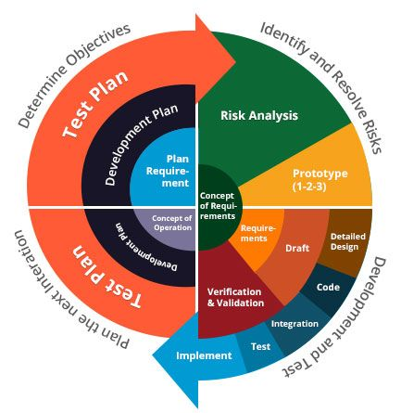This phase This also includes understanding the system requirements by continuous communication between the customer and the system analyst. At the end of the spiral the product is deployed in the identified market.

* Prototype Model

The basic idea here is that instead of freezing the requirements before a design or coding can proceed, a throwaway prototype is built to understand the requirements. This prototype is developed based on the currently known requirements. By using this prototype, the client can get an “actual feel” of the system, since the interactions with prototype can enable the client to better understand the requirements of the desired system. Prototyping is an attractive idea for complicated and large systems for which there is no manual process or existing system to help determining the requirements. The prototype is usually not complete systems and many of the details are not built in the prototype. The goal is to provide a system with overall functionality.

Requirement Gathering

Quick Design

Building Prototype

Engineer Product

Refining Prototype

Customer Evaluation

Start

Stop

5.3 Future Enhancements

A good project is one which never stops developing according to the changing situations and technologies there is a lot of scope of future enhancements.

* Online Payment.
* Online Teaching.
* Student Attendance.
* Online Mock Tests.
* New User To-Do List.

5.4 Bibliography

For the successful working of my project, I have referred many sources for the code snippets, logic and tips and tricks from the various books as well as web sites. Most I searched for the required possessions on the google.com search engine.

* Web Link:

1. google.com
2. w3schools.com

5.5 Appendices

The project Aavishkar Institute is the customize working on Admission of students and provides online material to them.

The software takes care of all requirement and helps to the students for taking admission easily.

We have successfully designed, coded and implemented our project with a lot of hard work.

Finally, I would like to thank our project guide Dr. Neha K. Shah for giving helpful guidelines for our project and also for giving suggestions when difficulties raised in our project.

5.6 Glossary

ASP : Active Server Pages

CSS : Cascading Style Sheets

DFD : Data Flow Diagram

ERD : Entity Relationship Diagram

GUI : Graphical User Interface

HTML : Hyper Text Markup Language

IDE : Integrated Development Environment

ISO : International Organization for Standardization

PERT : Program Evaluation Review Technique

RDBMS : Relational Database Management System

SOAP : Simple Object Access Protocol

SDLC : Software Development Life Cycle

SRS : Software Requirements Specification

SVG : Scalable Vector Graphics

SQL : Structured Query Language

T-SQL : Transact SQL

W3C : World Wide Web Consortium

XHTML : Extensible Hyper Text Markup Language

XML : Extensible Markup Language

XUL : Extensible User Interface Language

Thank You